How To Submit a Service Request

These are the ways that you can access a service request form to submit a work order for any maintenance-type services you need.
Please note, service requests can be submitted via a mobile device *must be on Eagle Net to access

- Type go.tntech.edu/workorder in your browser and hit enter. Choose the appropriate form option for your building and/or service needs then complete the required portions.
- When logged in to Tech Express, use the QuickLink icon in the Campus Resources section. This will open the service request portal. Choose the appropriate form option for your building and/or service needs then complete the required portions.
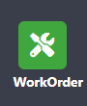
- From the Facilities & Business Services page on the website, choose request forms. Then choose Work Order Request to complete. The link will open in the service request portal. Choose the appropriate form option for your building then complete the required portions.

Service Request Portal- this landing page is where all service requests will be submitted. While these forms look alike, needing similar types of information, these are processed differently on our end so less information is needed from you, the requestor, when submitting. We have streamlined the process as much as possible.

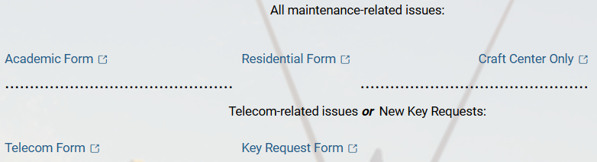
4
5
3
2
1
- Academic-any request for Academic/Administrative Buildings & Grounds
- Res. Life-any request for Residential Buildings & Grounds
- Craft Center Only-any request related to Craft Center Buildings & Grounds only
- Telecom-any request related to Telecom services for any Academic/Administrative and Residential Buildings
- Key requests-all buildings, include signed key request forms

Service Request Form- the form is the same for the requester no matter which form (except the key request form, details below) is used. However, it flows through to the right team within the system. All items with red asterisk (see yellow arrows) must be entered. These items include contact information, location, and request description.
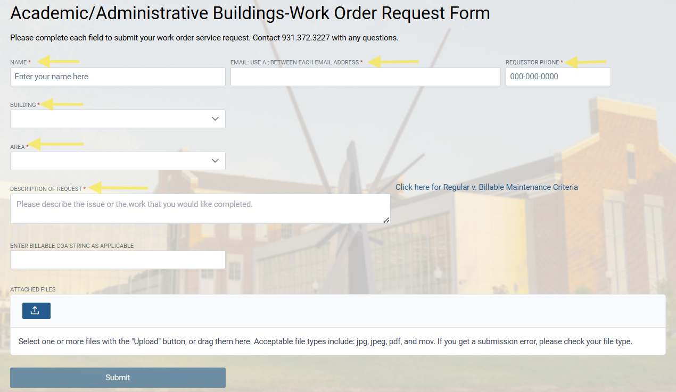

Building: Click in the box to see a scrollable, alphabetical list of buildings. If you begin typing the building name, options will begin to populate. The more letters you type, the more refined your search. Please note, the room number or ‘area’ will not be an option until you choose your building. This will show all academic and housing buildings on campus. *Craft Center locations are only visible on the Craft Center form

FOR TECH VILLAGE
Begin typing “Tech Village” into your search bar and options begin to populate. Feel free to include your unit number in your request description if you are unsure if East or West.
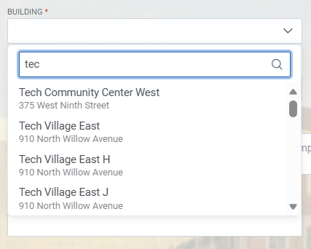
Area: Click in the box to see a scrollable, numerical list of areas. If you begin typing the room number, options will begin to populate. This works by typing the room type, such as ‘rest’ for restrooms. The more digits/letters you type, the more refined your search. Please note, the room number or ‘area’ will not be an option until you choose your building. This will show all academic and housing areas on campus associated to the building you chose. *Craft Center locations are only visible on the Craft Center form

FOR TECH VILLAGE
This will be a combination of your building information and unit number with the letter designation and the digit, example: R3. You will see a scrollable, numerical list or you can type the digit of the unit and that will generate.
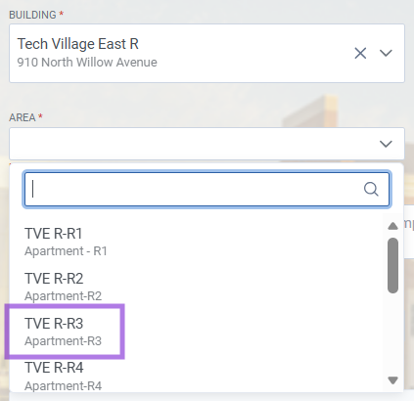

Key Request Service Form- Please utilize this form as it is the only way to submit a key request. No forms will be accepted by email, interoffice mail, or in person. As a reminder, you must attach the signed new key request form when submitting.

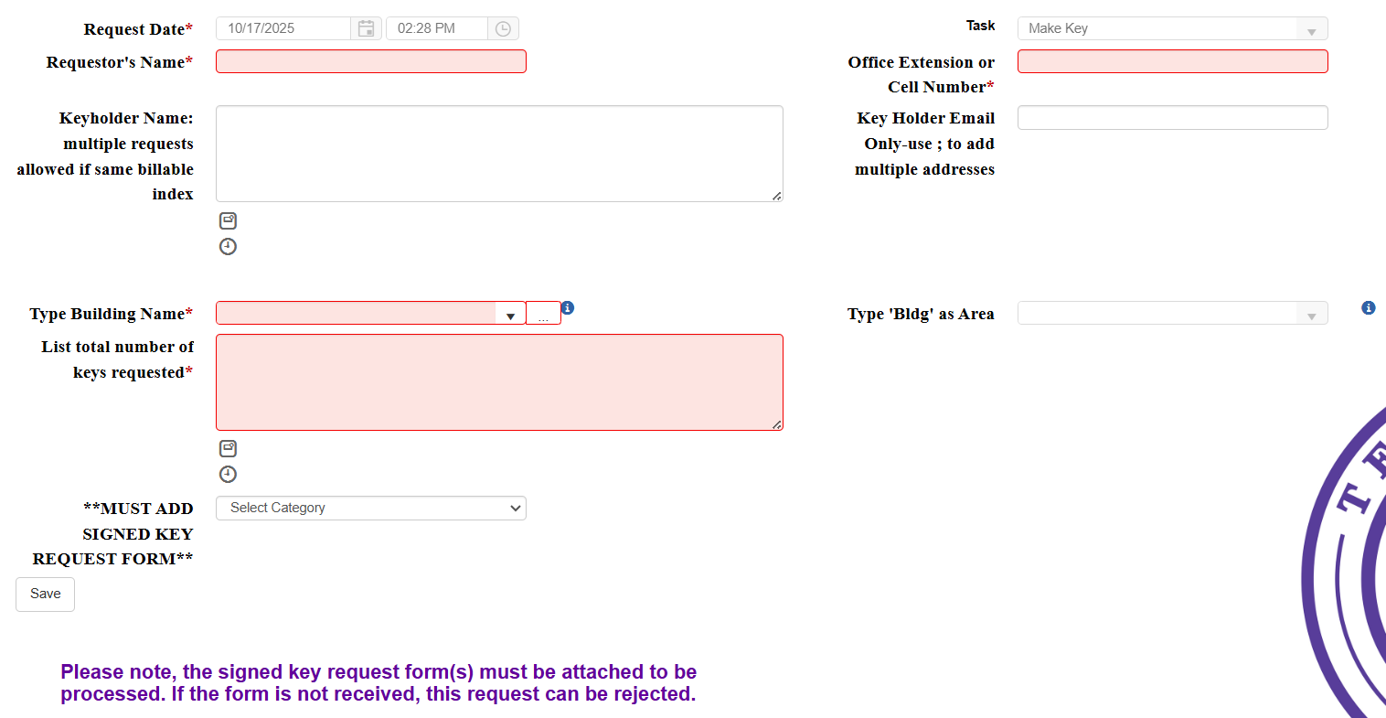
Requestor Name and Office Extension: Enter your name and contact number. In the Keyholder Name box-enter the name of the keyholder who you are requesting keys for. If using the same index, you may submit multiple forms on the same request. Ensure you use a ; to separate each keyholder’s email address.
Building Name and Area: Enter the building in which keys are needed for. If multiple buildings on the same form, enter one of those buildings. Begin typing the building name in the field and the list will auto-populate. Make sure you choose the building once populated to activate the area field. For area, begin typing bldg and that option will auto-populate. Again, choose that option.
Key Total: Enter the total number of keys needed from the requests being submitted.
Attachment: Attach the appropriately completed and signed key request form for each keyholder.

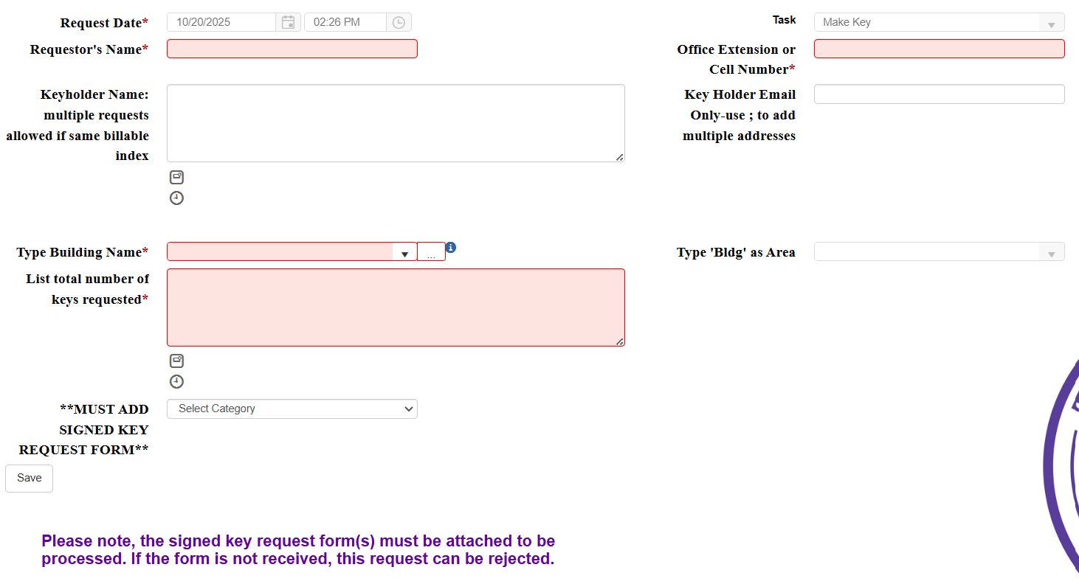

Feel free to reach out to facilities@tntech.edu
or at extension 3227 for any issues.

