# **How To Submit a Work Order**

**These are the ways that you can access a service request form to submit a work order for any maintenance type services you need.**

1. **Type go.tntech.edu/workorder in your browser and hit enter. Choose the appropriate form option for your building then complete the required portions.**

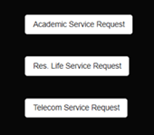

1. **When logged in to Tech Express, use the QuickLink icon in the Campus Resources section. This will open in the request home page. Choose the appropriate form option (Res Life Service Request) for your building then complete the required portions.**



1. **From the Facilities & Business Services page on the website, choose request forms. Then choose Work Order Request to complete. The link will open in the request home page. Choose the appropriate form option for your building then complete the required portions.**

**Service Request Home Page**- this landing page is where all service requests will be submitted. Although each request form looks the same and accesses the same building information, these are processed differently on our end so less information is needed from the requestor when submitting. We have streamlined the process as much as possible.

*Please note, service requests can be submitted via a mobile device *must be on Eagle Net to access*

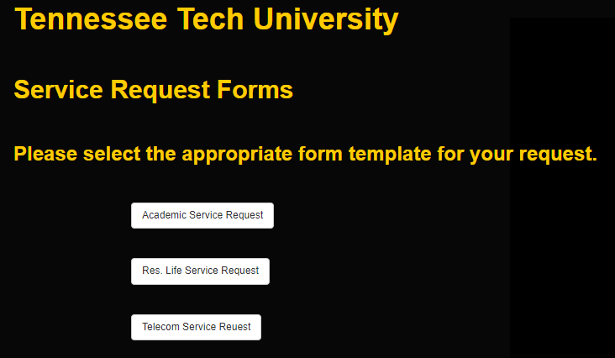

**Service Request Form**- the form is the same for the requester no matter which form is used. However, it flows through to the right team within the system. All items in red must be entered. These items include contact information, location, and request description.

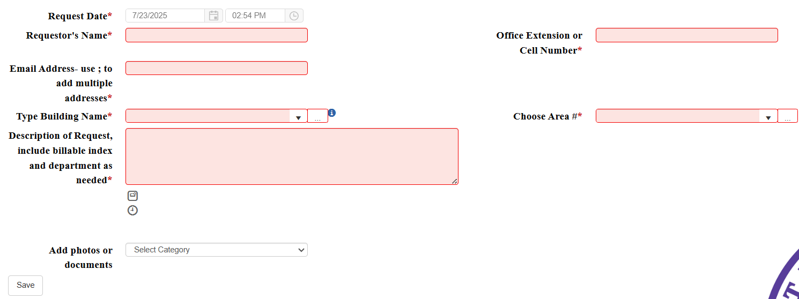

**Building:** Begin typing your building name and a populated list will show with options. Please note, the room number or ‘area’ will not be an option until you choose your building. This will show all academic and housing buildings on campus. You can just click in the box and see all the building names or click on the 3 dots.

***3 dots to see listing***

*\*\*Click into the box for complete listing*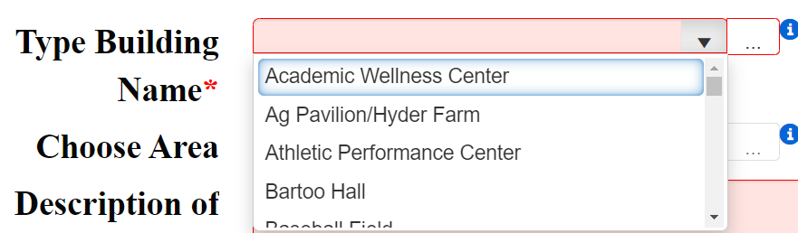

*\*\*Begin typing building*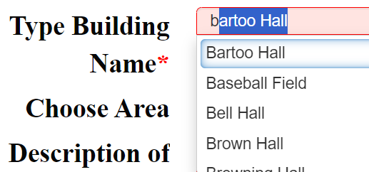

FOR TECH VILLAGE

Begin typing “Tech Village” into your search bar and options begin to populate. Feel free to include your unit number in your request description if you are unsure if East or West.

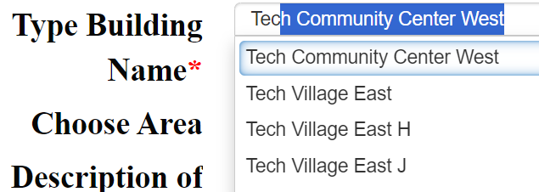

**Area:** The area works the same; begin typing room number, click into the search bar to see complete list or click on 3 dots.

FOR TECH VILLAGE

This will be your unit number with the letter designation and the digit, example: H3

**Feel free to reach out to** [**facilities@tntech.edu**](mailto:facilities@tntech.edu)

**or at extension 3227 for any issues.**