Here are how things worked out, according to ChatGPT (**Proposal 3** is the winner!):

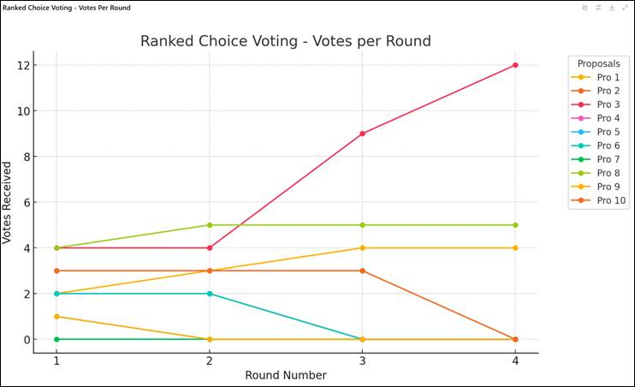

**Round 1: Initial Vote Count**

Each voter’s **first-choice votes** are counted.

* Proposal 7: 0 votes
* **Proposal 3 & Proposal 8:** 4 votes each
* **Proposal 10:** 3 votes
* **Proposal 2 & Proposal 6:** 2 votes each
* **Proposal 4 & Proposal 1:** 2 votes each
* **Proposal 9 & Proposal 5:** 1 vote each (Lowest)

🔹 **Proposal 7, 9 & Proposal 5 are eliminated** (since they received the fewest votes).  
🔹 Their votes are redistributed to each voter's **next choice**.

**Round 2: Redistribution After Eliminations**

The eliminated proposals' votes go to the **next-ranked choices** on those ballots.

* **Proposal 8 gains 1 extra vote** (from P3, the person who voted for #9 as their first choice) (total: **5**)
* **Proposal 7 was already eliminated.**
* **Proposal 3 stays the same** (total: **4**)
* **Proposal 10 stays the same** (total: **3**)
* **Proposal 2 stays the same** (total: **2**)
* **Proposal 6 stays the same** (total: **2**)
* **Proposal 4 stays the same** (total: **2**)
* **Proposal 1 gains 1 extra vote** (total: **3**)

🔹 **Proposal 9 & Proposal 5 were already eliminated.**  
🔹 Now, **Proposal 2 & Proposal 6 are eliminated** (since they still have the fewest votes).  
🔹 Their votes are redistributed.

**Round 3: More Redistributed Votes**

Now that **Proposal 2 & Proposal 6** have been eliminated, their votes go to the **next available choices** on voters' ballots.

* **Proposal 3 jumps up to 9 votes**
* **Proposal 8 stays at 5 votes**
* **Proposal 10 stays at 3 votes**
* **Proposal 4 stays at 2 votes**
* **Proposal 1 increases to 4 votes**

🔹 **Proposal 4 is eliminated (fewest votes).**  
🔹 Votes for **Proposal 4** are redistributed.

**Round 4: Another Proposal is Eliminated**

With **Proposal 4 eliminated**, those votes go to **remaining choices**.

* **Proposal 3 reaches 12 votes**
* **Proposal 8 stays at 5 votes**
* **Proposal 10 is eliminated (0 votes left)**
* **Proposal 1 remains with 4 votes**

🔹 **Proposal 10 is eliminated.**  
🔹 No need for another round—**Proposal 3 has the majority (>50%) and is declared the winner!** 🎉

**Final Winner:**

🏆 **Proposal 3 wins with 12 votes!**  
🔹 Proposal 8 was the second most popular option with 5 votes.  
🔹 Proposal 1 held on until the end but only got 4 votes.

**Key Takeaways:**

1. **Proposal 3 started with only 4 votes** but steadily gained support as other proposals were eliminated.
2. **Proposals 9 and 5 were eliminated early** due to lack of support.
3. **Once Proposal 3 reached 12 votes, it crossed the 50% threshold** and won outright.
4. **No single proposal had a strong lead initially, but the process ensured a winner with majority support.**

**Checked by hand and….**

I got 13 votes for #3 in the last round and 8 votes for #8 in the last round, so I got the same winner as ChatGPT. In the round before that, I got 8 votes for #3, 6 votes for #6, and 7 votes for #8. I think the difference is what happens when proposals are tied in a given round. I’ll dig into the tiebreaker rules to see if I can reproduce the ChatGPT results.