Table of Contents
Quantitative Reasoning & Analysis 3
QRA Choice Rationale 4
3 hours: 4
Min: 3 hours 5
3 to 6 hours 6
QRA Choice Ranking 6
Humanities & Cultural Expression 7
HCE Choice Rationale 8
6 hours 8
Min: 6 hours 8
3 to 9 hours 9
HCE Choice Ranking 10
Literature Req. Choice and Rationale 10
Yes 11
No 11
Historic Foundations 13
HiFo Choice Rationale 14
6 hours 14
Min: 3 hours 14
3 to 6 hours 15
6 to 9 hours 15
HiFo Choice Ranking 16
Social & Behavioral Sciences 17
SBS Choice Rationale 18
6 hours 18
Min: 6 hours 18
3 to 6 hours 18
6 to 9 hours 19
3 to 9 hours 19
SBS Choice Ranking 19
Communication 20
Comm Choice Rationale 21
Min: 6 hours (min: 3 composition; min: 3 oral) 21
6 to 9 hours (min: 3 composition; min: 3 oral) 22
6 to 9 hours (min: 6 composition) 22
9 hours (6 composition; 3 oral) 22
9 hours (min: 3 composition; min: 3 oral) 23
Comm Choice Ranking 25
Scientific Reasoning 26
SR Choice Rationale 27
8 hours 27
Min: 4 hours 28
4 to 8 hours 29
SR Choice Ranking 30
Proposals 31
Rationale 32
Proposal 1 32
Proposal 2 32
Proposal 3 32
Proposal 4 33
Proposal 6 33
Proposal 8 33
Proposal 10 34
Ranking 34
Final Thoughts 35

Quantitative Reasoning & Analysis
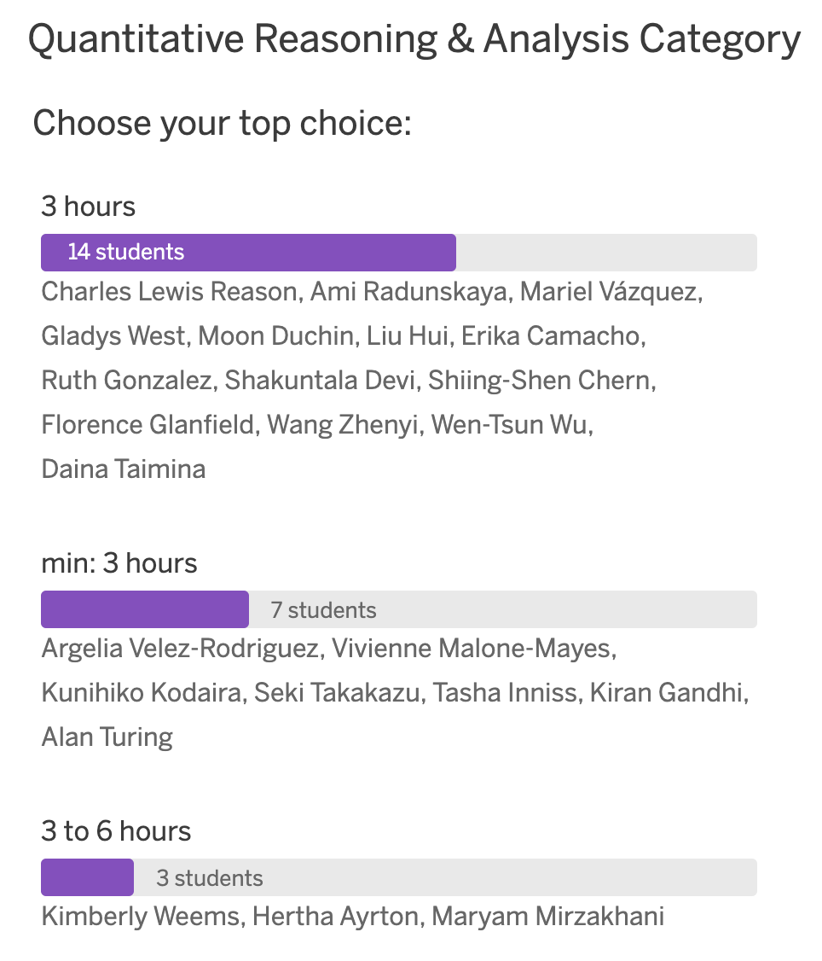

QRA Choice Rationale

3 hours:
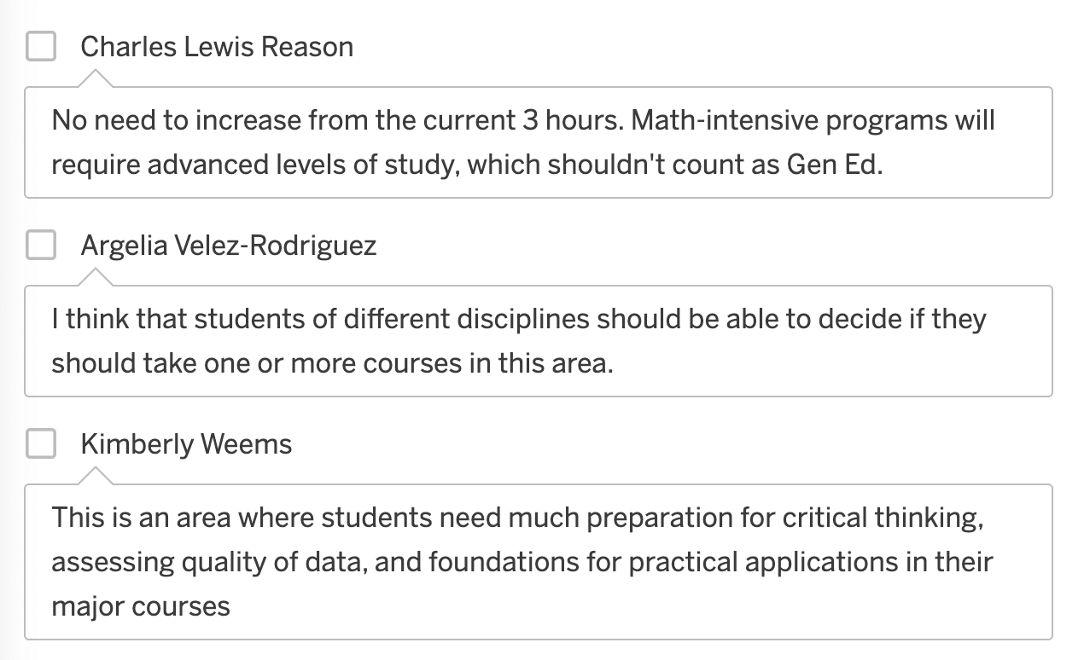
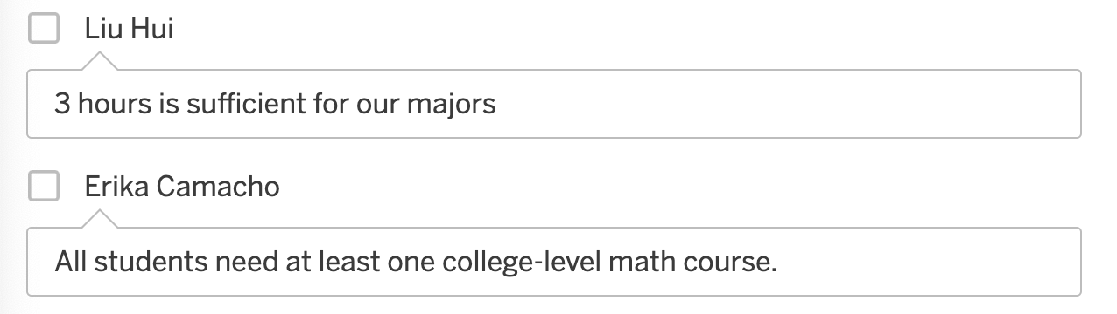
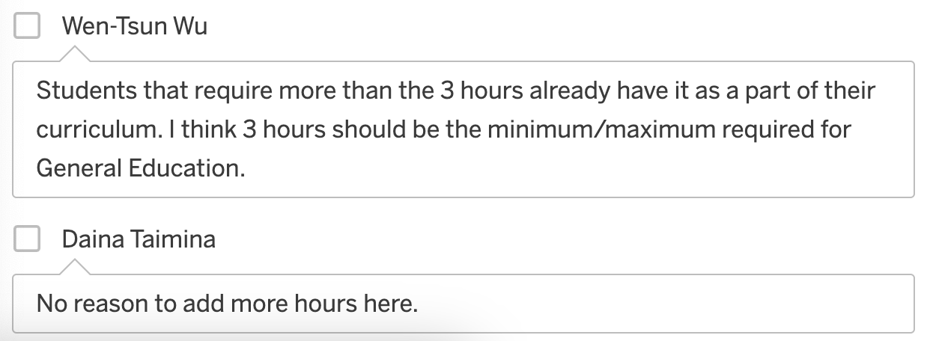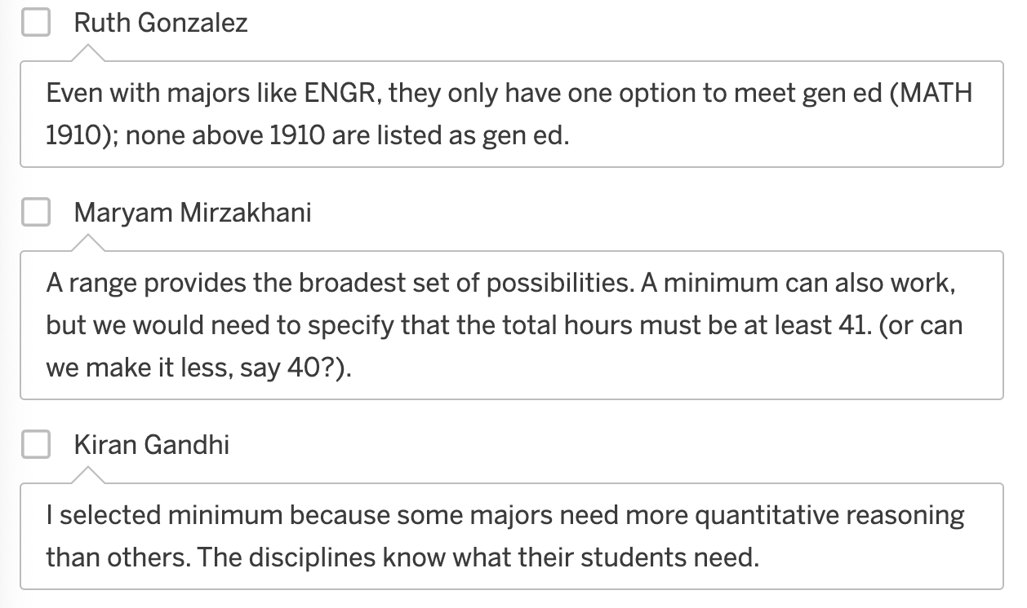
Min: 3 hours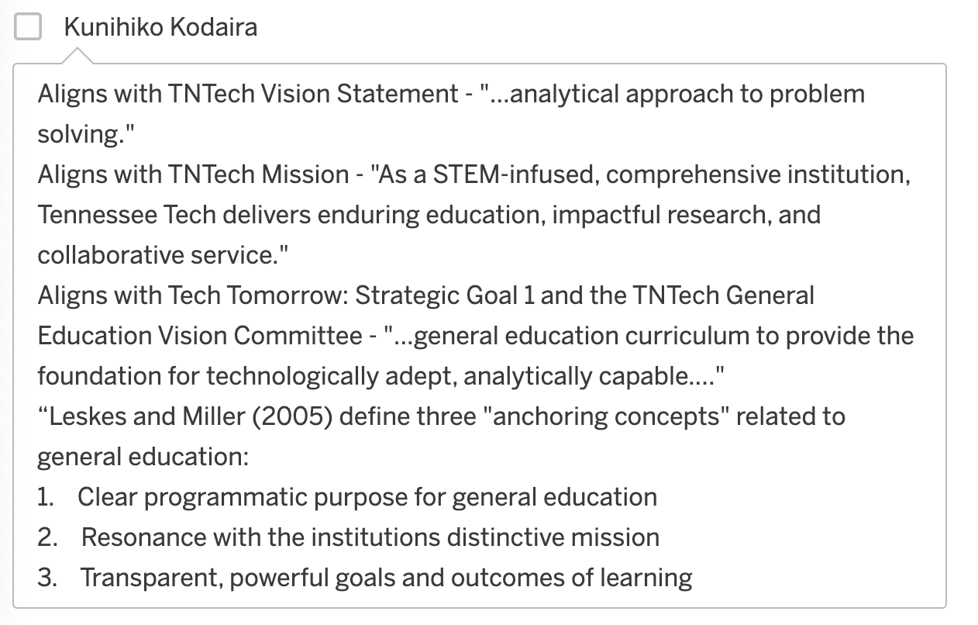

3 to 6 hours

QRA Choice Ranking
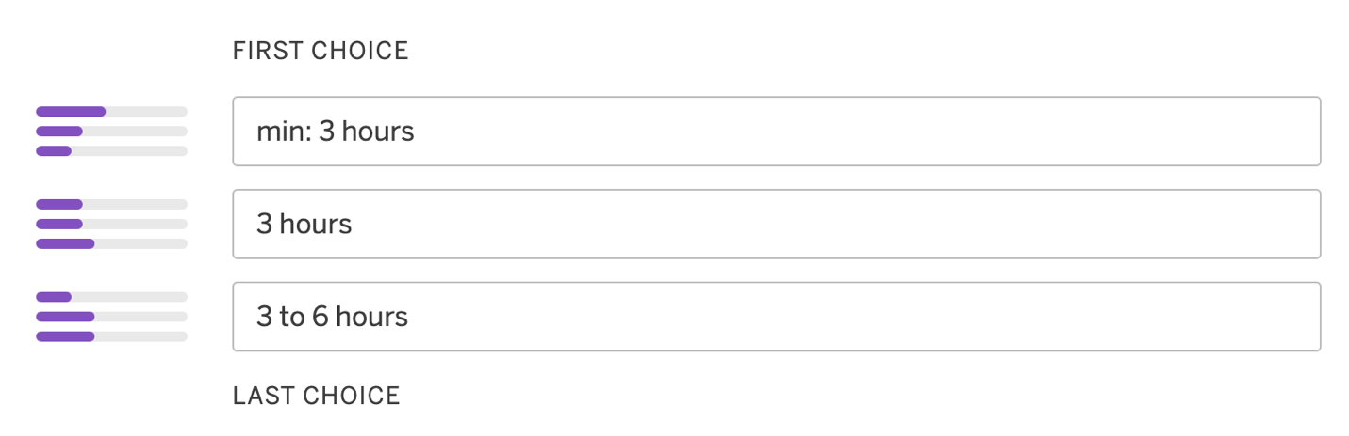

Humanities & Cultural Expression
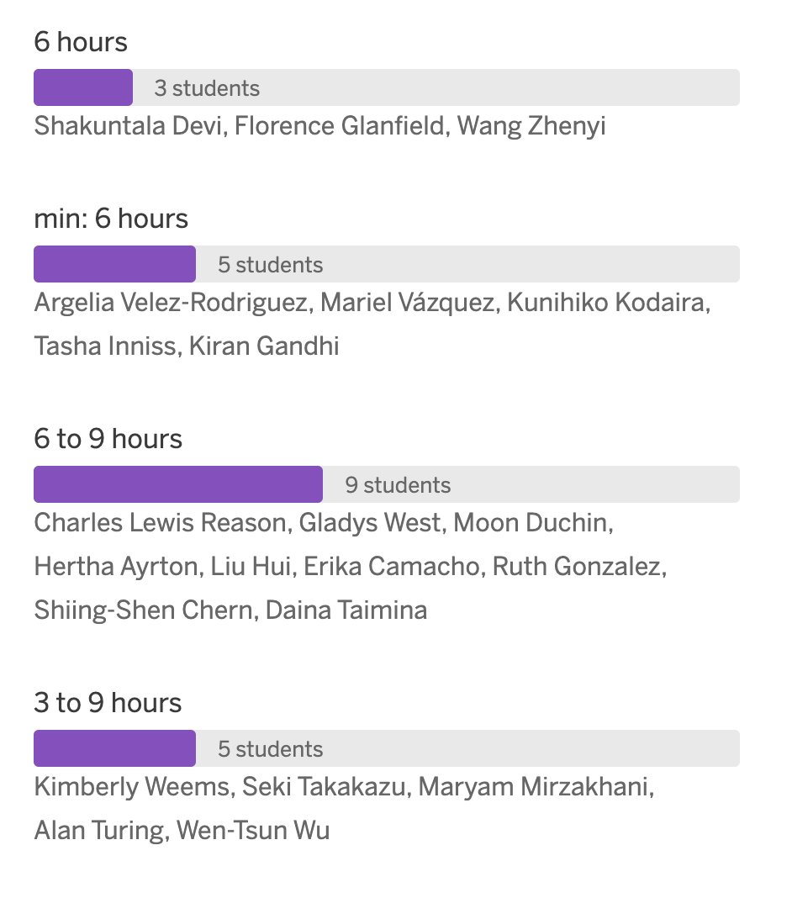

HCE Choice Rationale

6 hours
No rationale provided for this choice.

Min: 6 hours
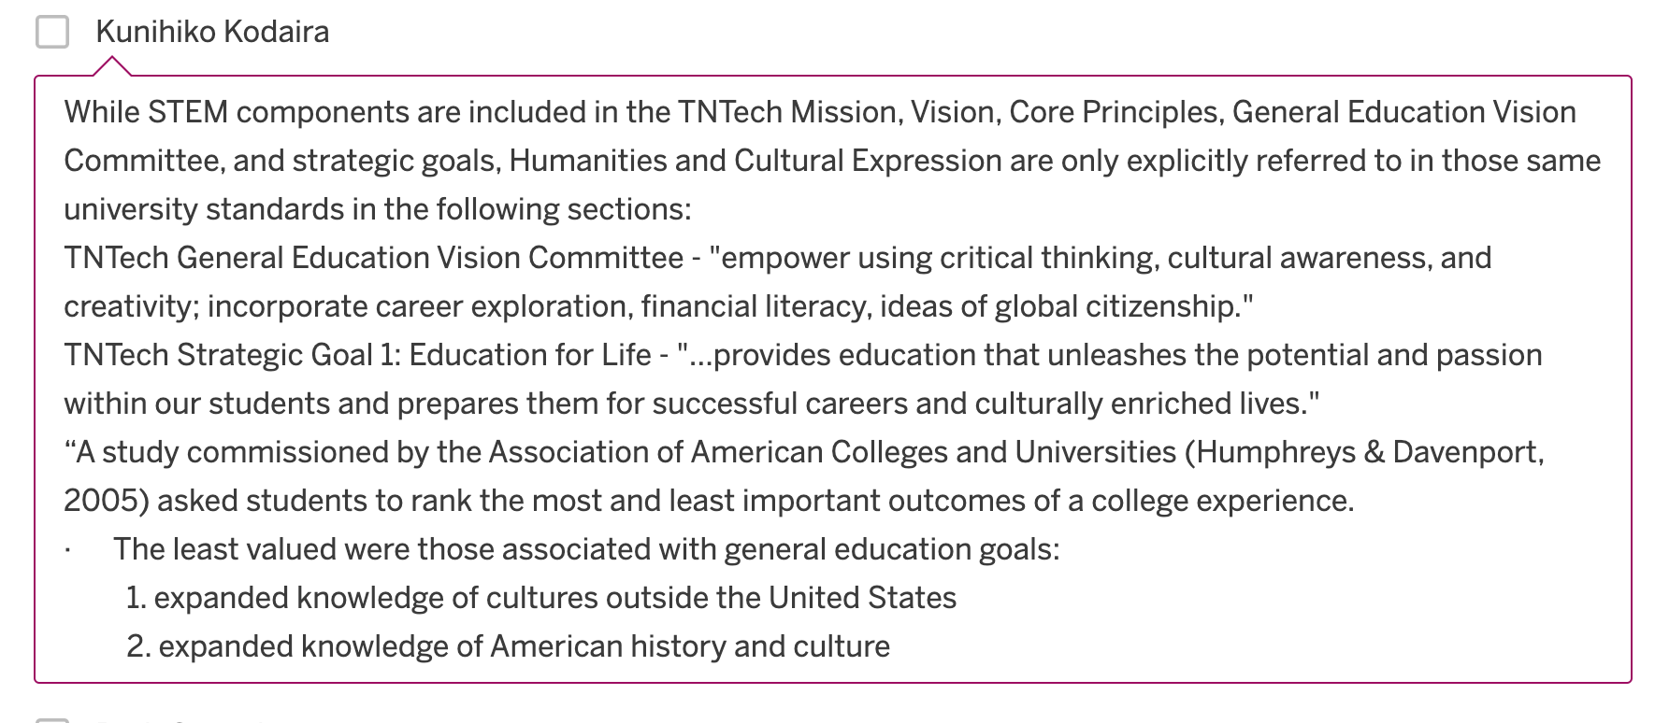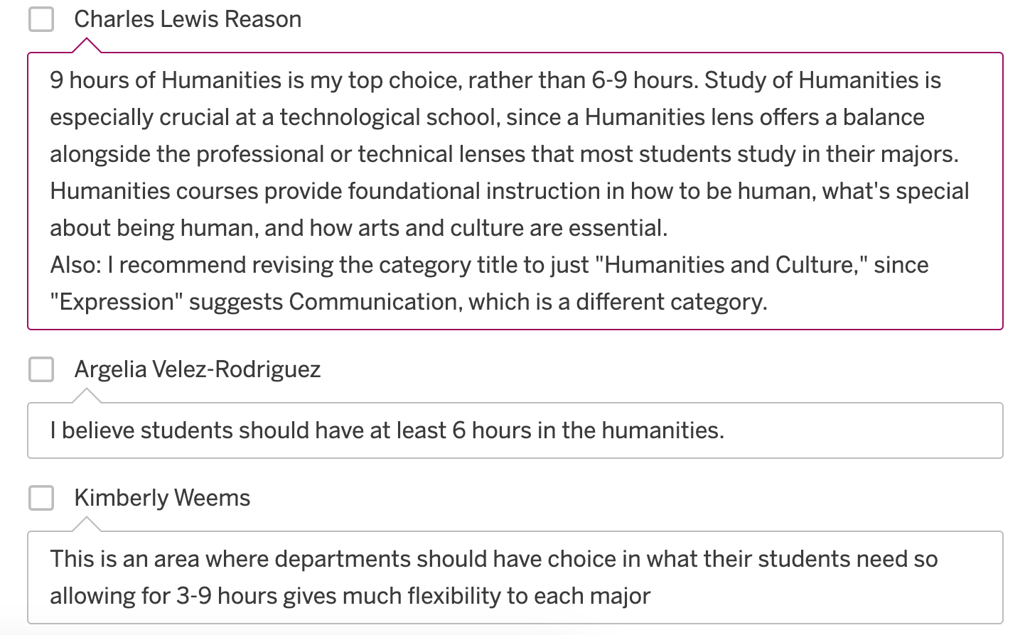6 to 9 hours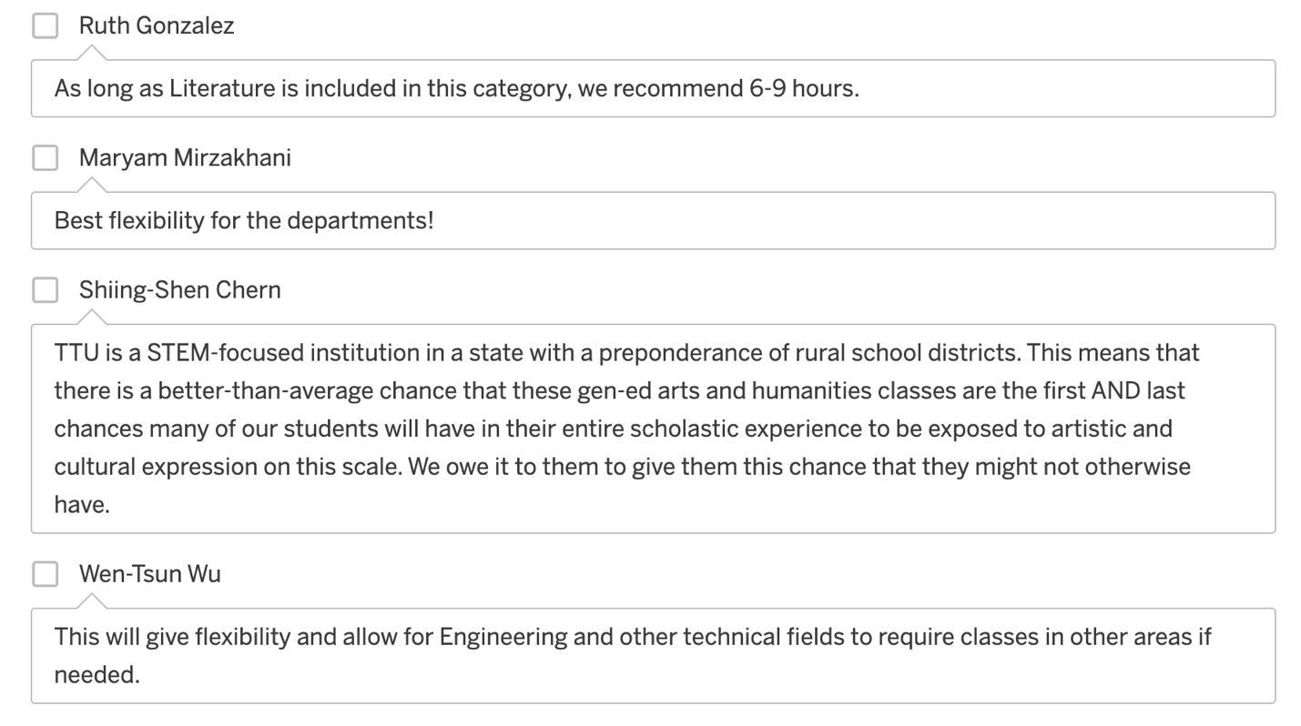
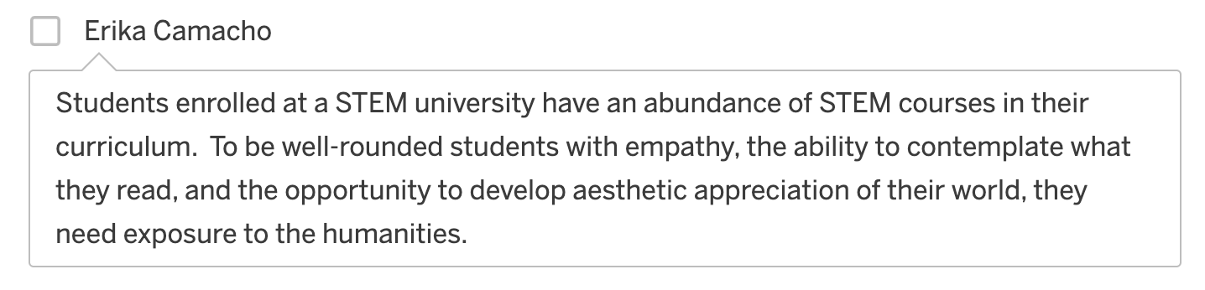
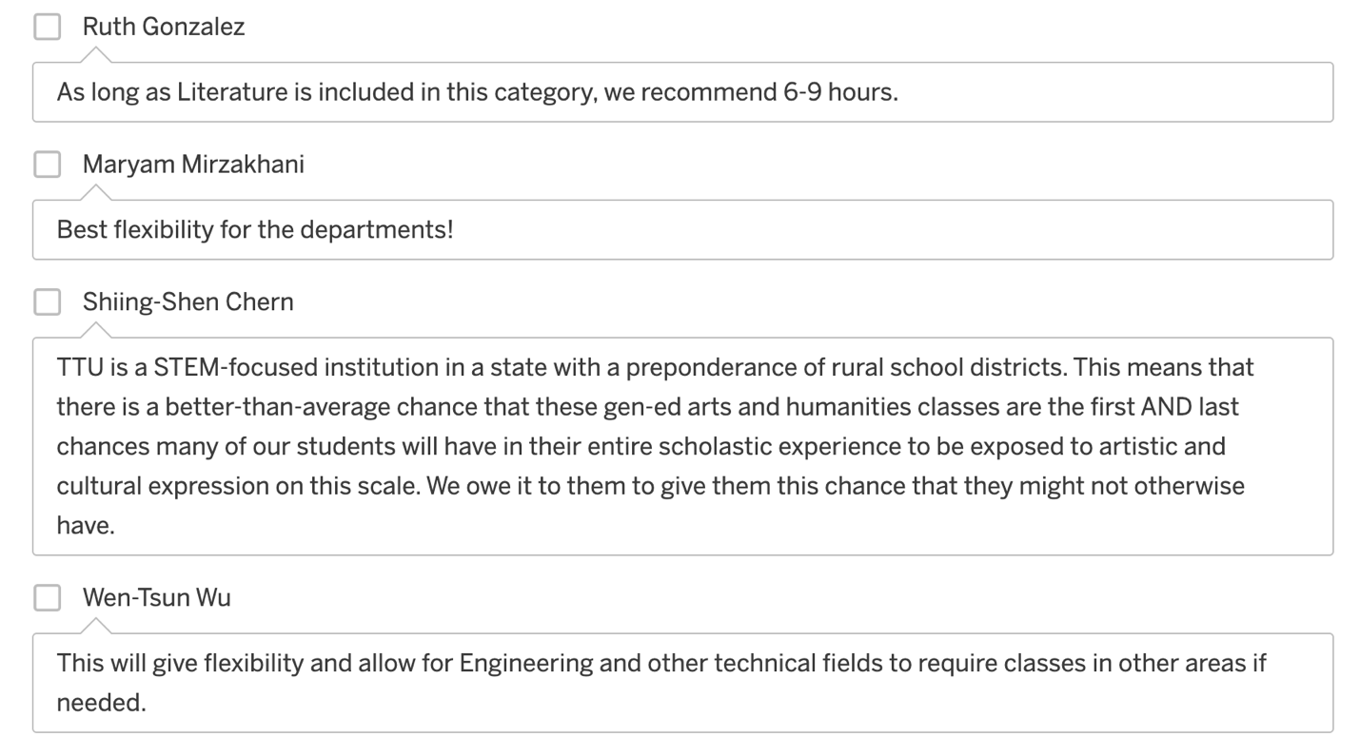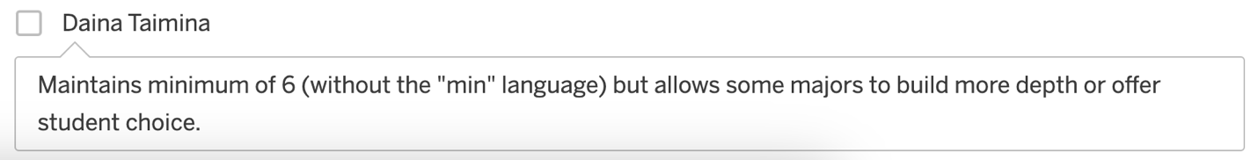

3 to 9 hours

HCE Choice Ranking
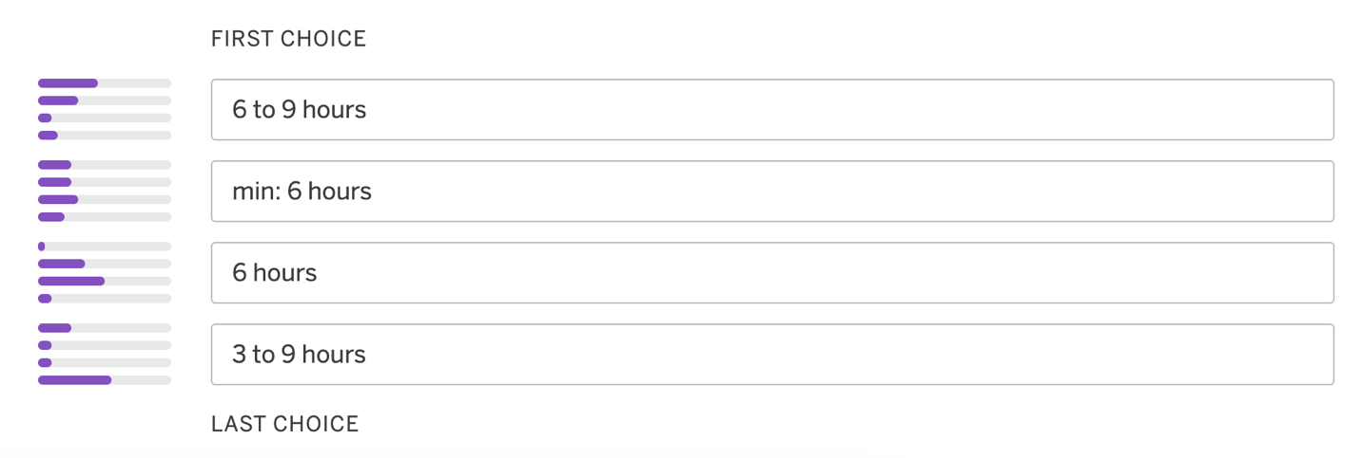

Literature Req. Choice and Rationale
Do you think we should require all students in all majors to take a literature course within the Humanities & Cultural Expression Category?
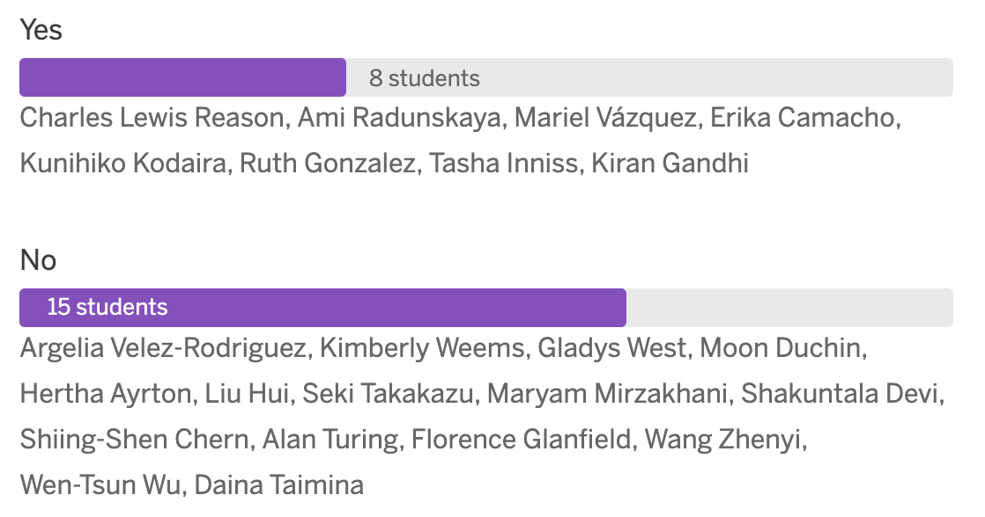

Yes
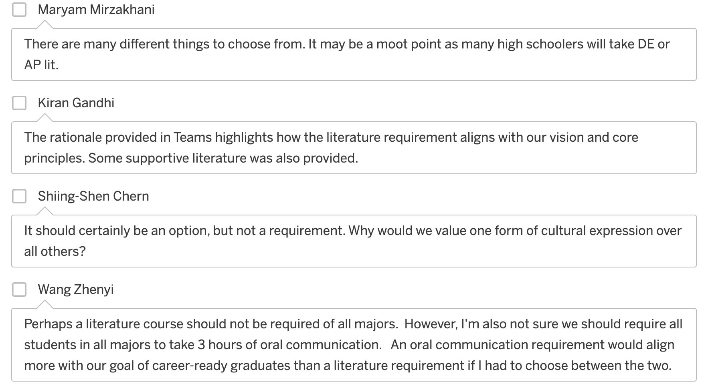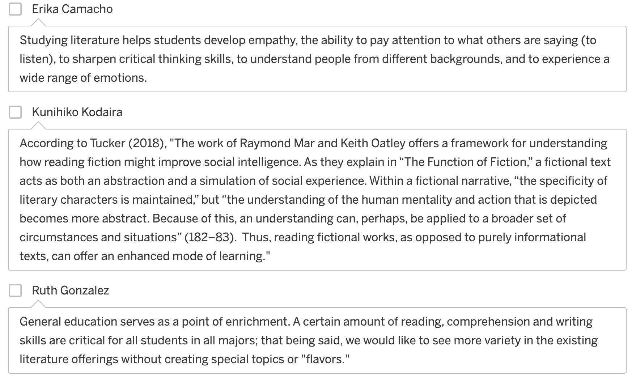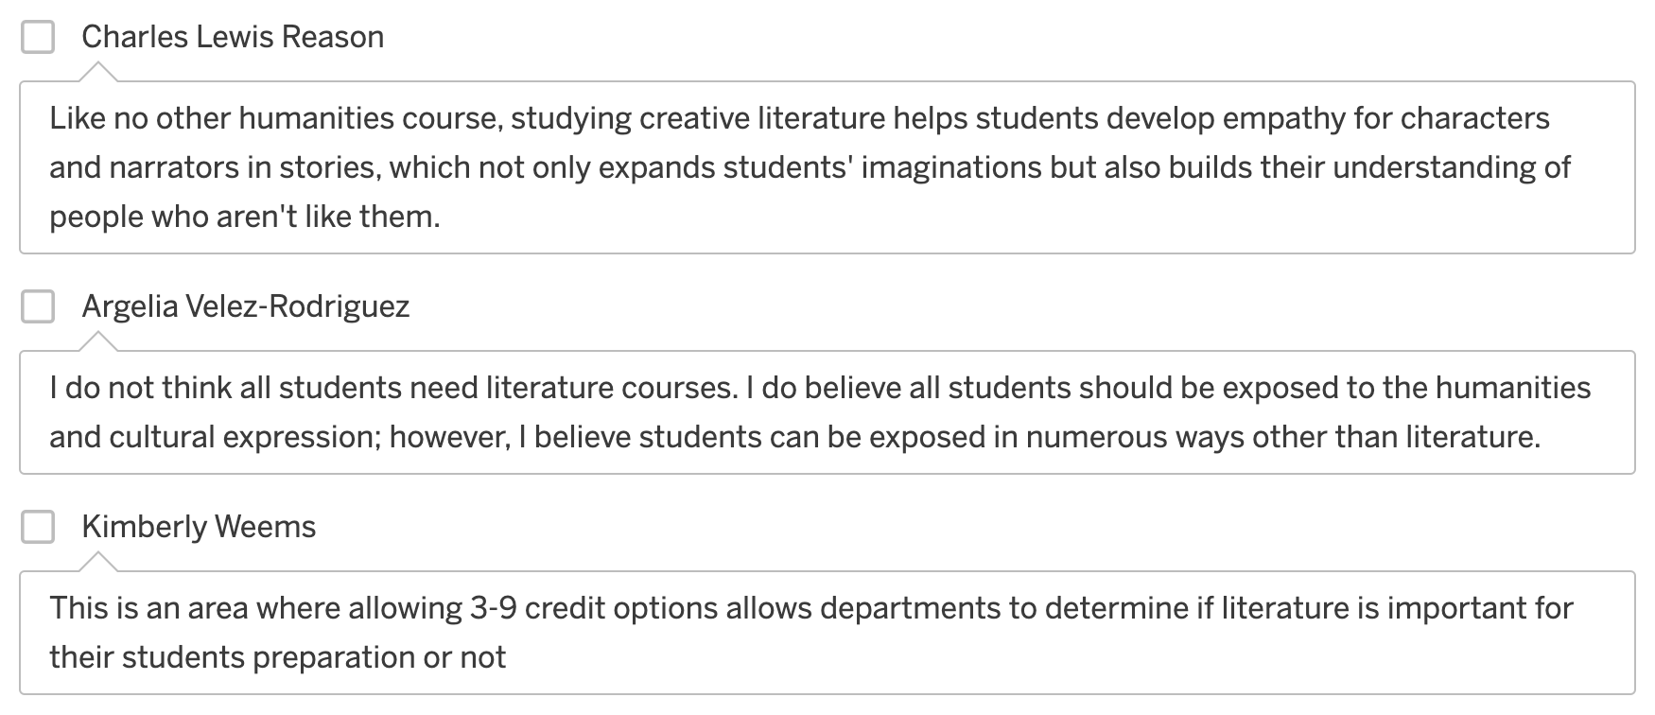

No
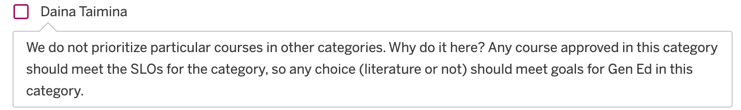

Historic Foundations
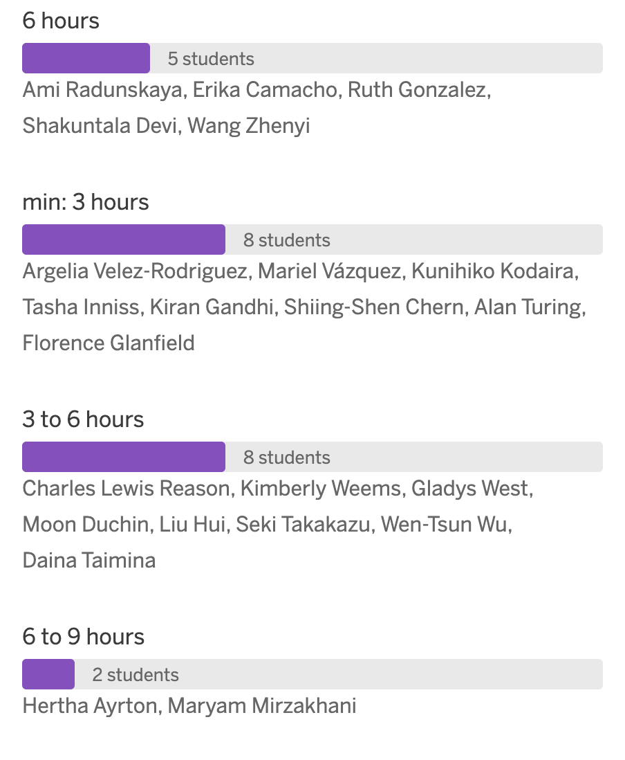

HiFo Choice Rationale

6 hours
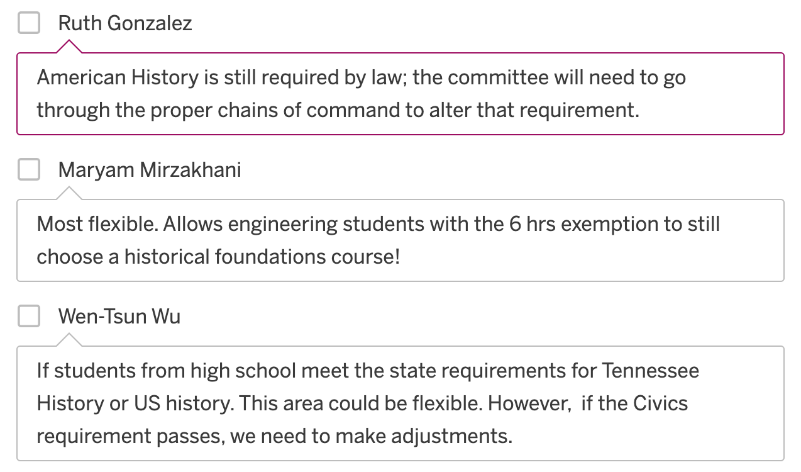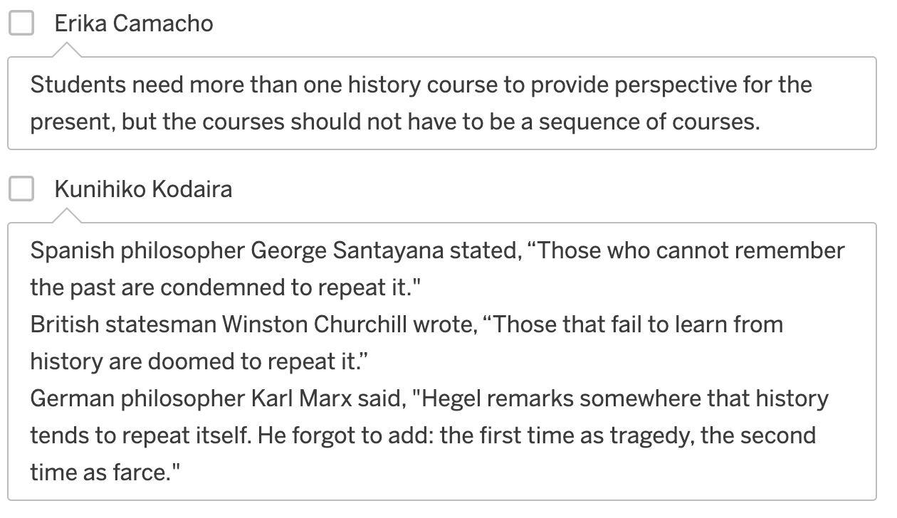

Min: 3 hours
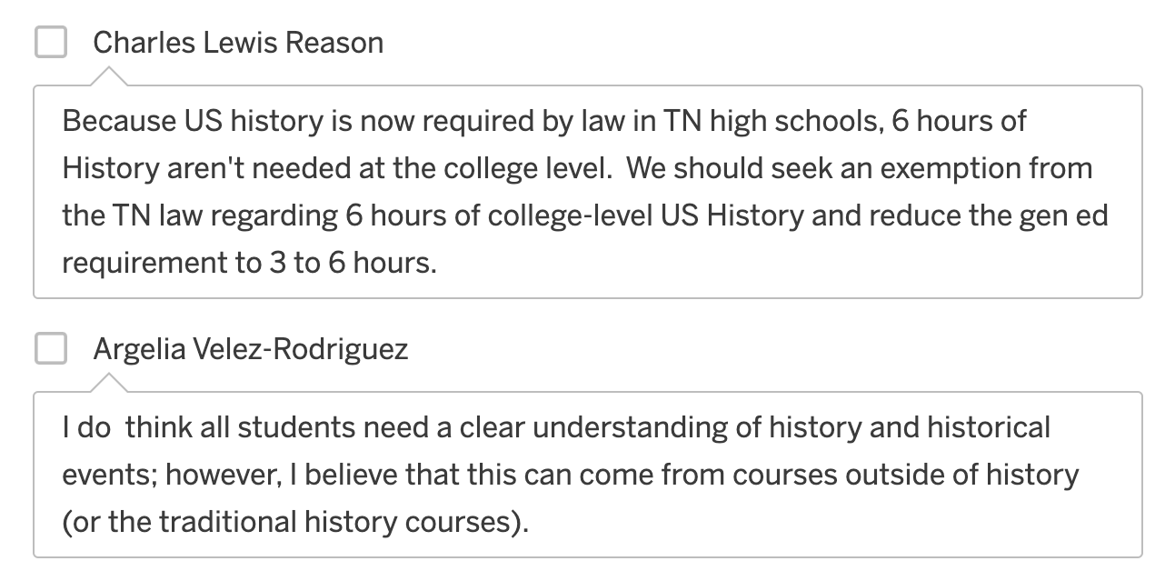

3 to 6 hours
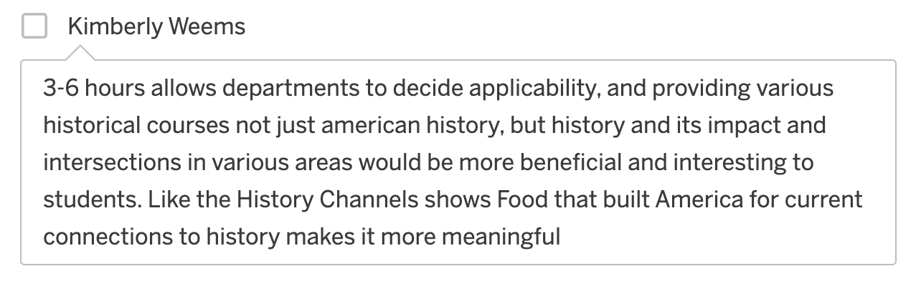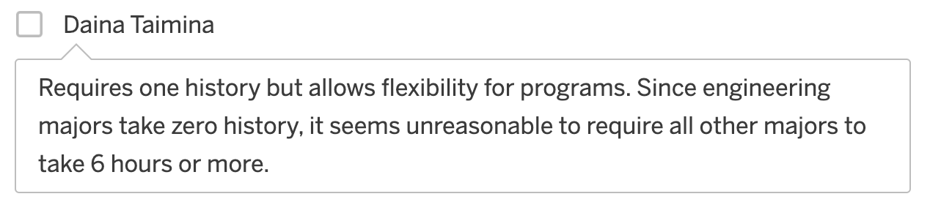

6 to 9 hours

HiFo Choice Ranking
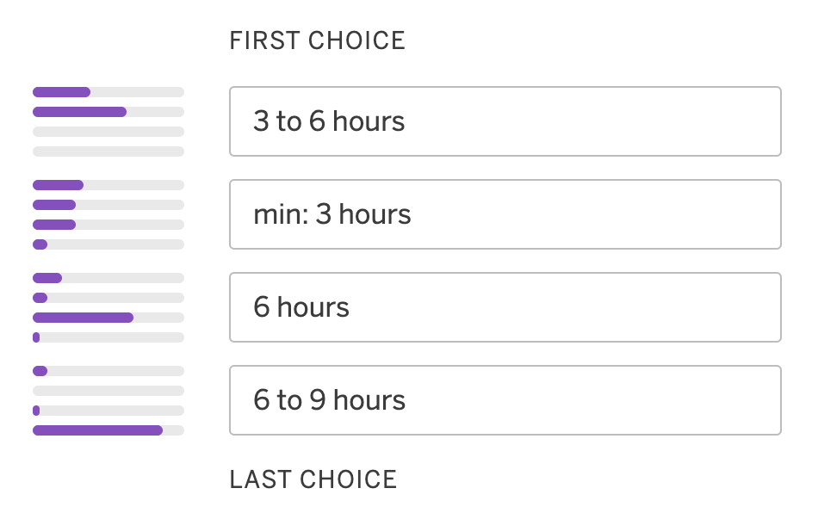

Social & Behavioral Sciences
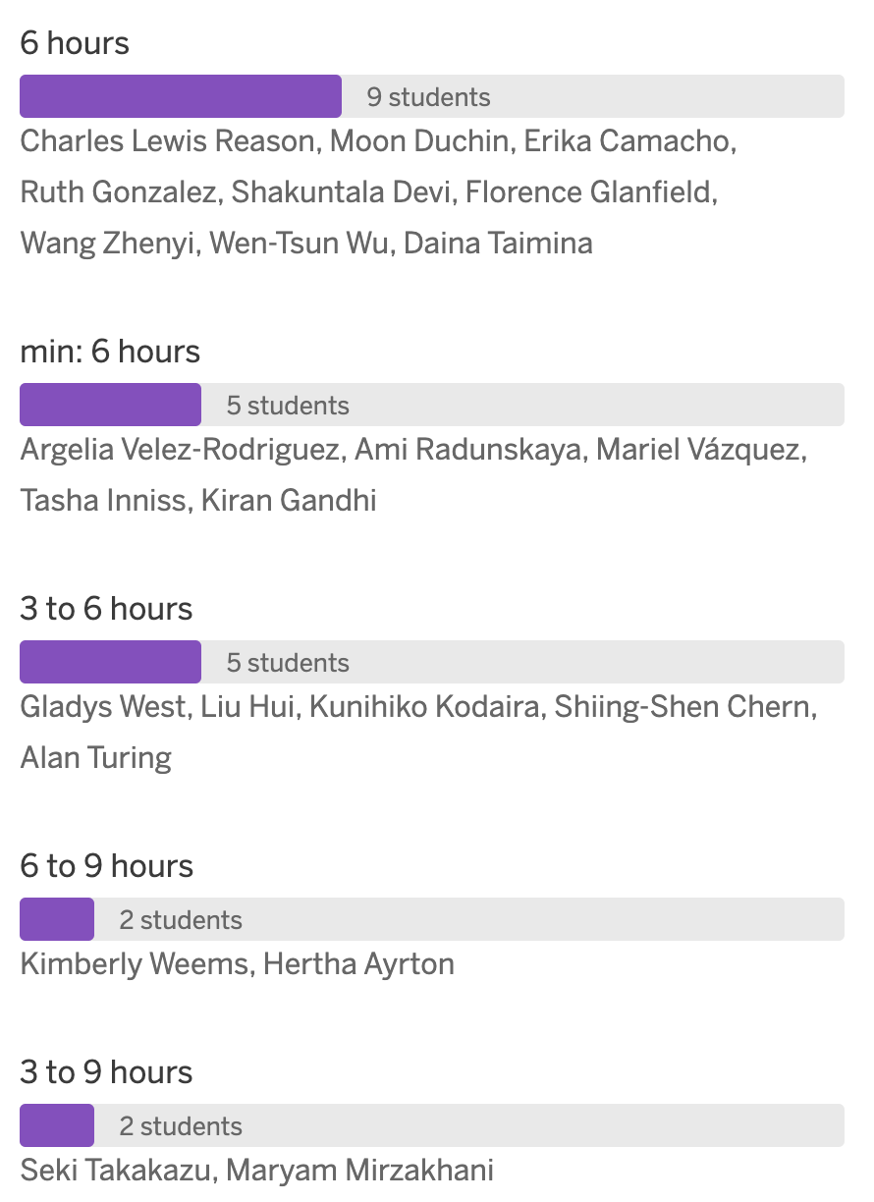

SBS Choice Rationale

6 hours
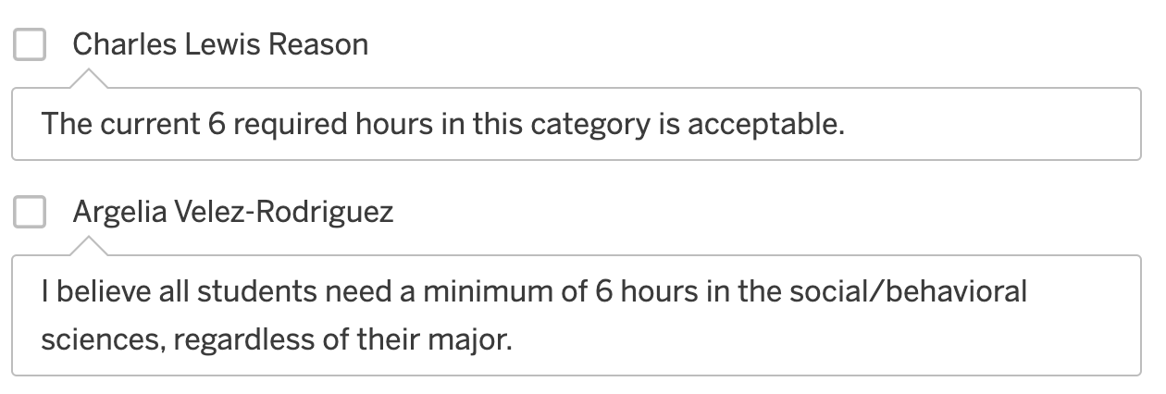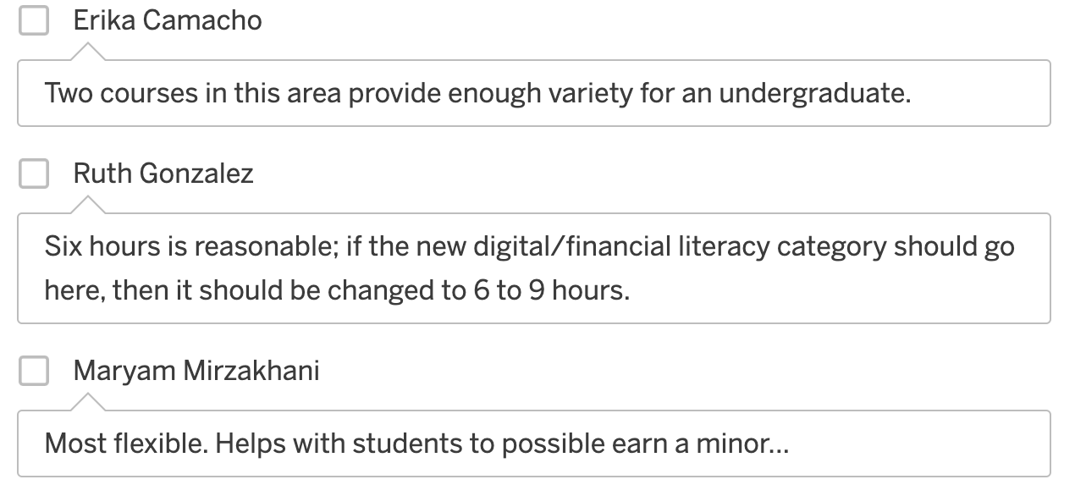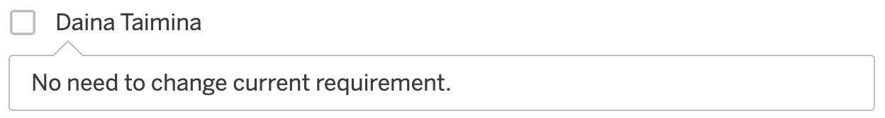

Min: 6 hours

3 to 6 hours
No rationale provided for this choice.

6 to 9 hours
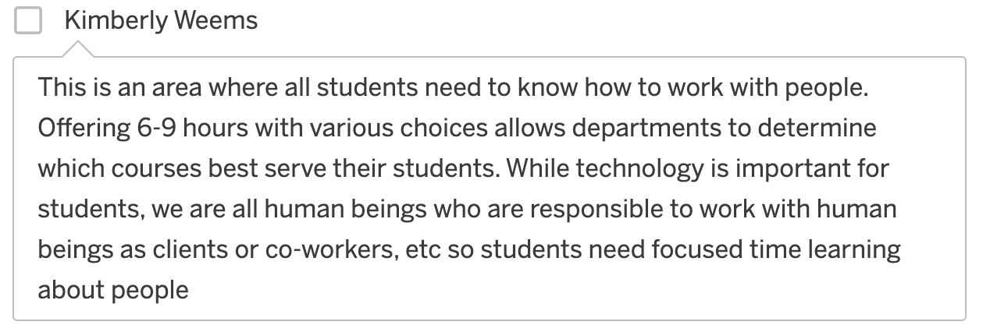

3 to 9 hours

SBS Choice Ranking
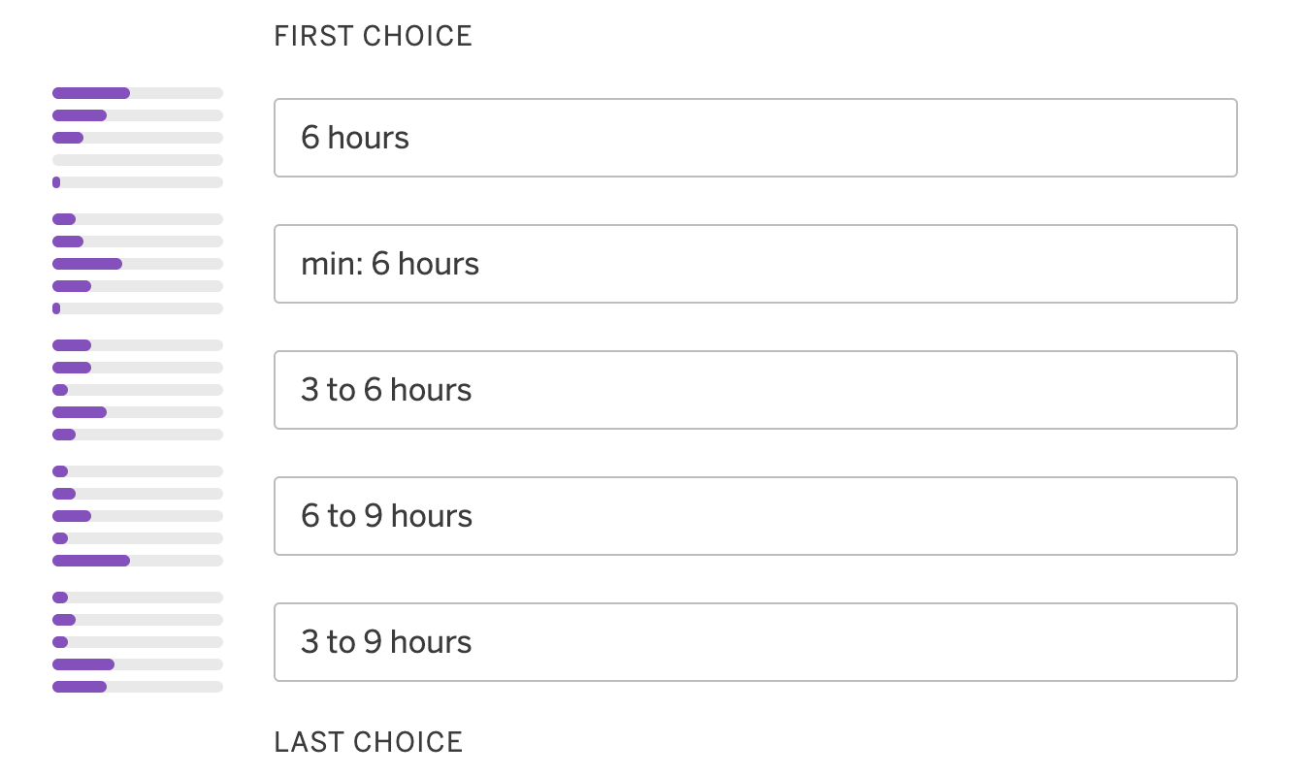

Communication
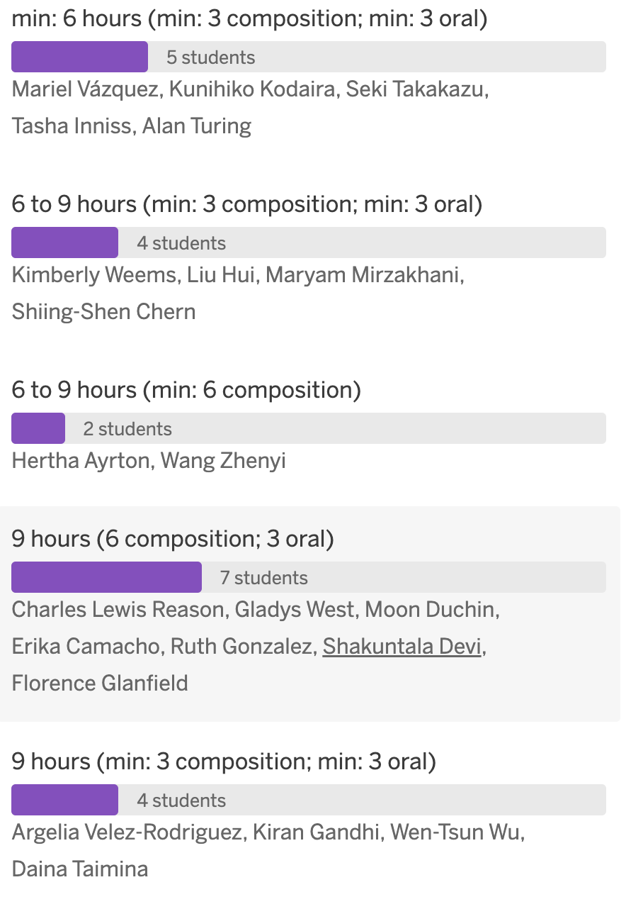

Comm Choice Rationale

Min: 6 hours (min: 3 composition; min: 3 oral)

Dahm et al. (2019) stated, "To continue driving science forward and be able to tackle global challenges, the art of good interdisciplinary communication needs to become a core skill in a scientist's portfolio." This reflects TNTech's STEM principles. From Newburger et al. (2024): "Over the first 2 decades of the 21st century, a series of three studies empirically affirmed that importance and provided support for the centrality of the communication discipline’s content and pedagogy (Morreale et al., 2000; Morreale & Pearson, 2008; Morreale et al., 2017). Similar to those three earlier studies, the results of a recent fourth study also argue that communication, and specifically oral communication education, is critical to students’ future personal and professional success (Morreale et al., 2023). Thematic analysis of 2,155 articles, identified in academic and popular press publications extending from 2016 to 2020, provides support for the centrality of the communication discipline’s content and pedagogy. Other research teams studied and reported about the opportunities for instructional communication scholars related to instructional preparedness and the transition to remote learning at the start of the 2020 pandemic (Morreale et al., 2020; Westwick & Morreale, 2021). Similar to this present essay, in 2023, Morreale and Westwick wrote about advocating for and valuing instructional and communication education across the academy. In support of these writings by communication scholars, effective communication skills often are listed as one of the most important skills for new employees and, as such, are often the focus of strategic planning and institutional initiatives to prepare students for the workforce. Strong communication skills are a critical component of almost any career; even more so as one advances in their respective fields. In 2021, the National Association of Colleges and Employers (NACE) listed verbal communication skills as fourth on a list of attributes sought by employers (up from seventh in 2020) with 73% of respondents looking for evidence of this skill (Gray, 2022). Communication skills are listed as a top requirement for any job, no matter the specific field; they are employers’ most required soft skill by far. Prior to the COVID-19 pandemic, 80% of business presentations were already virtual, and since then, that number has increased exponentially (Duarte, 2013)." Lobbying as a Means for Expanding the Communication Instructional Base in Higher Education III

6 to 9 hours (min: 3 composition; min: 3 oral)
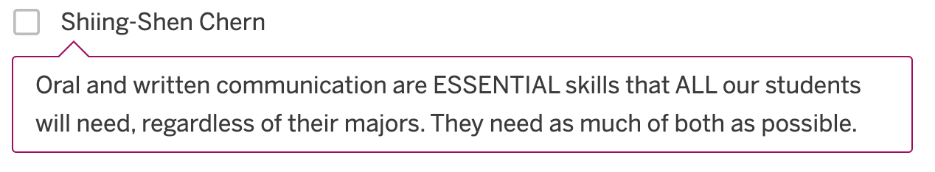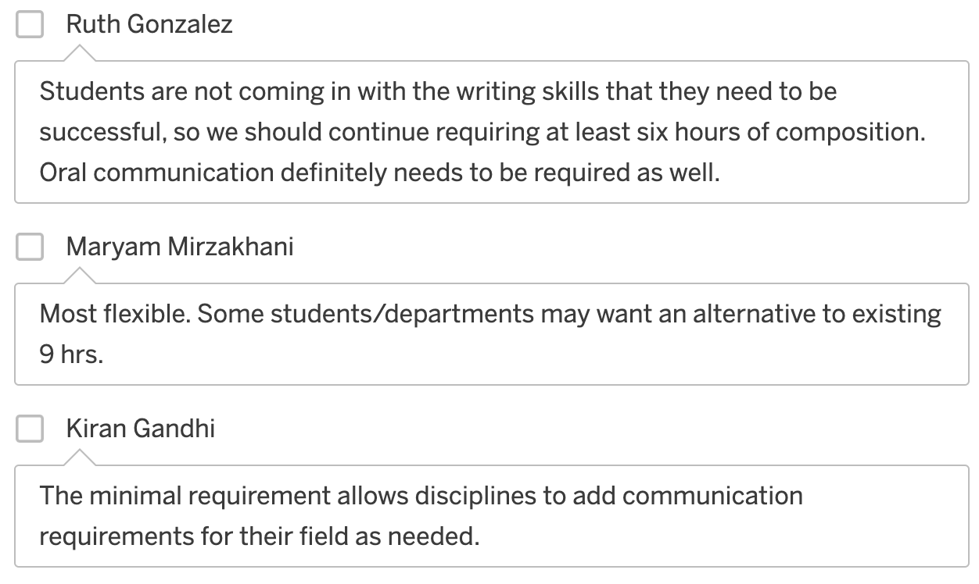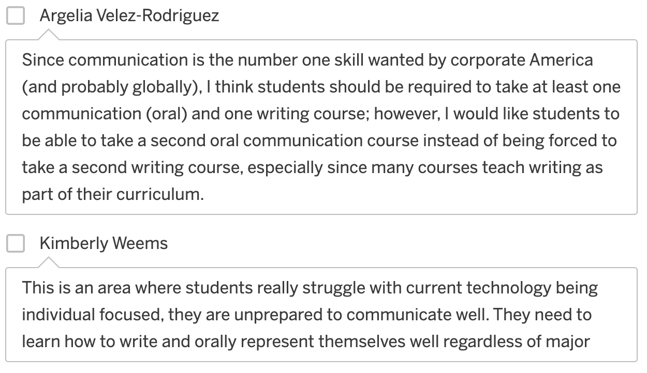

6 to 9 hours (min: 6 composition)
No rationale provided for this choice.

9 hours (6 composition; 3 oral)
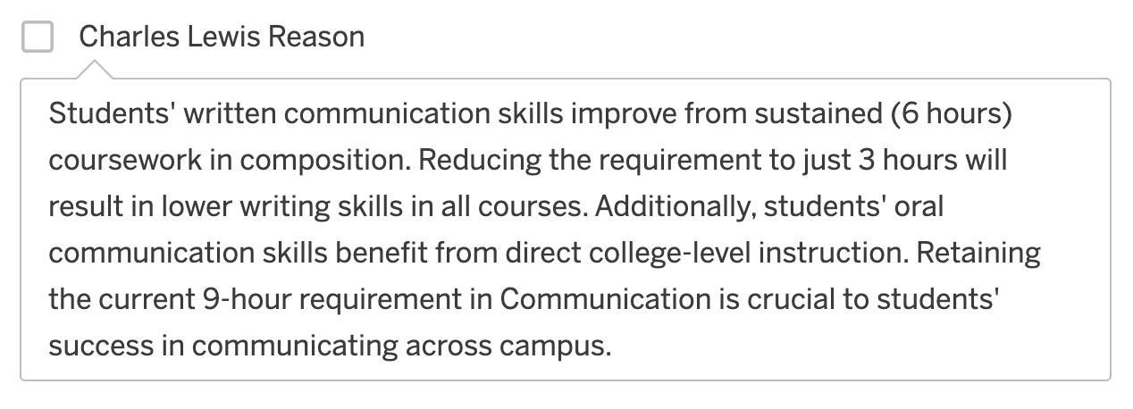
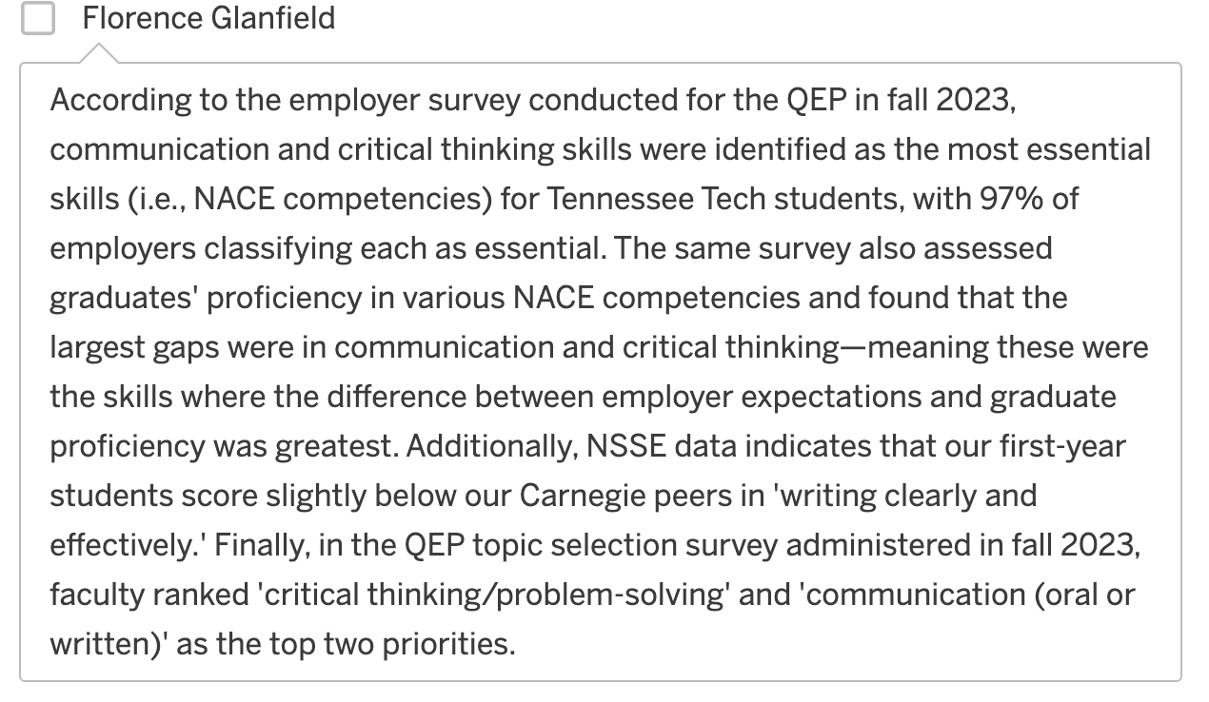
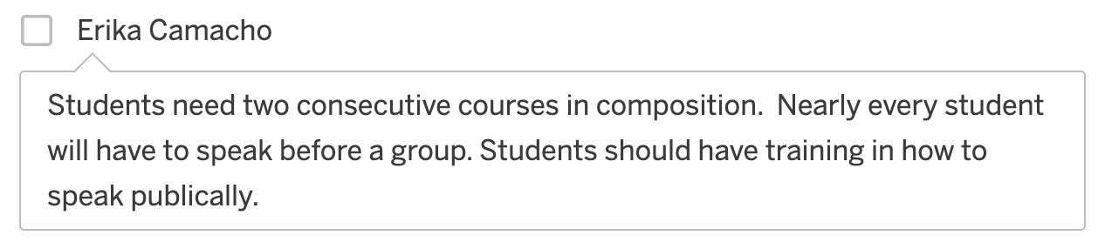

9 hours (min: 3 composition; min: 3 oral)
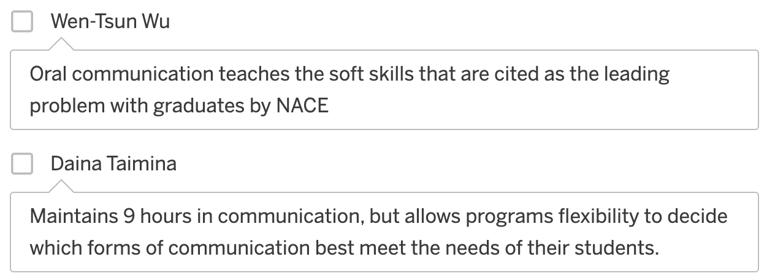

Comm Choice Ranking
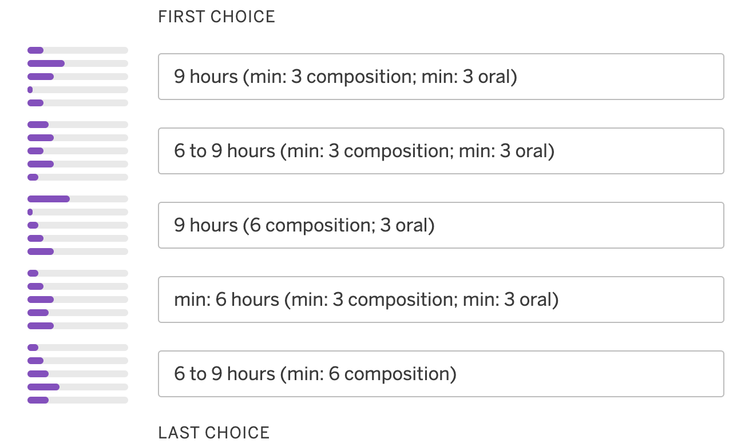

Scientific Reasoning
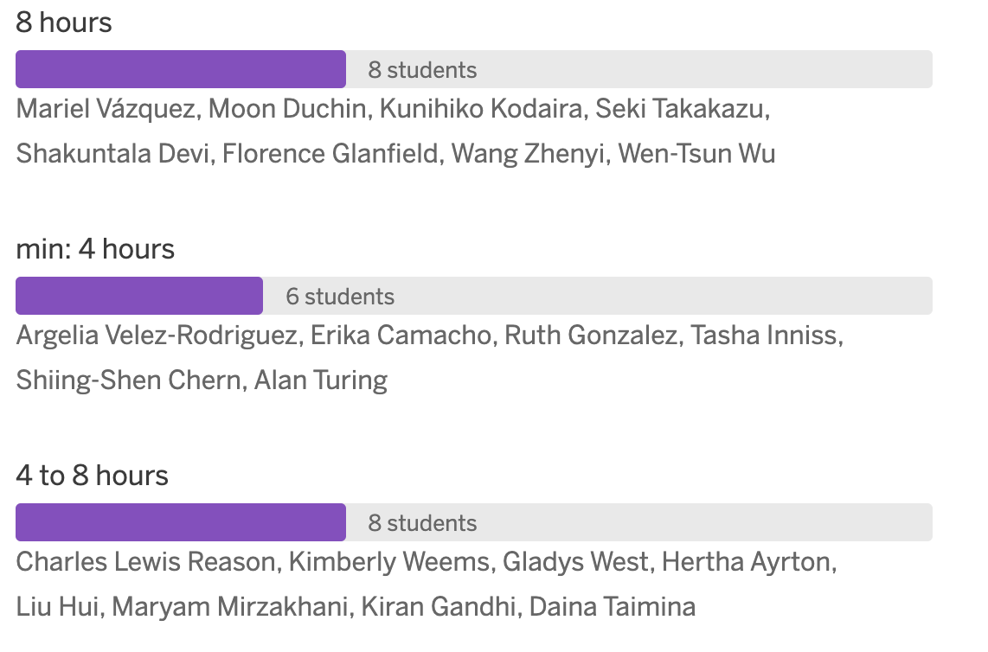

SR Choice Rationale

8 hours
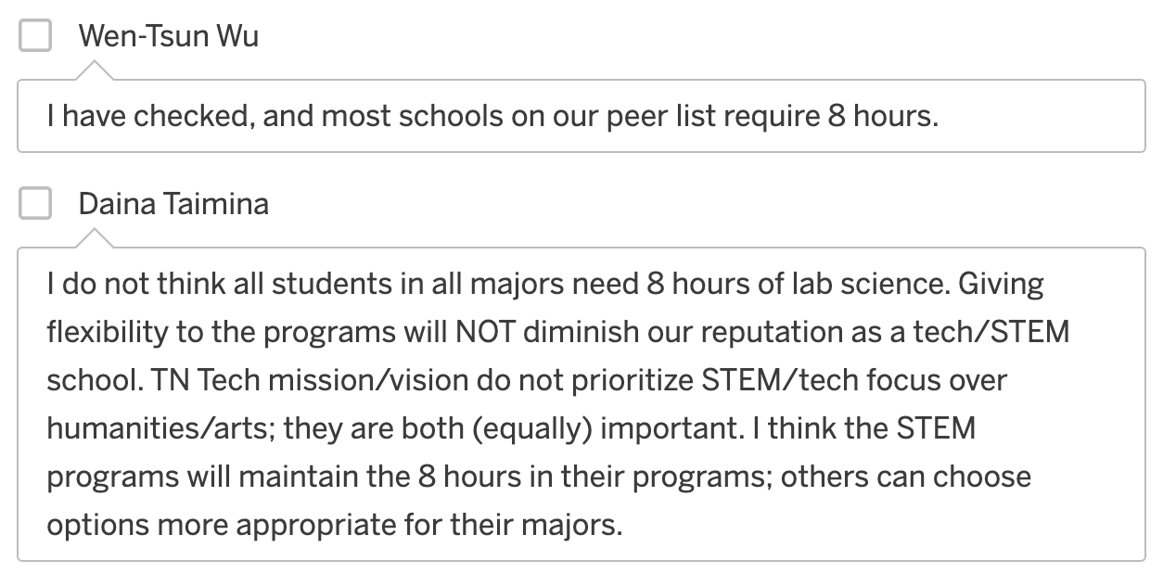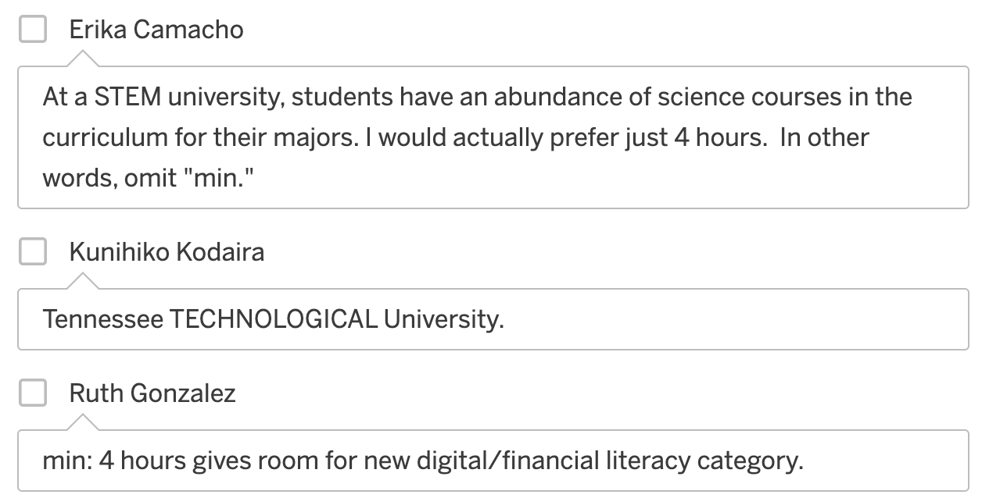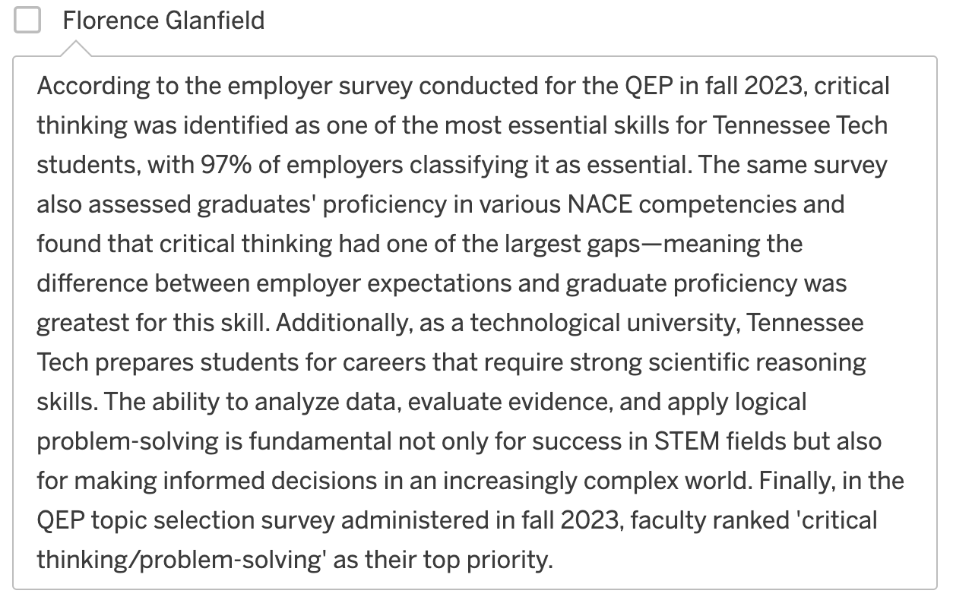

Min: 4 hours
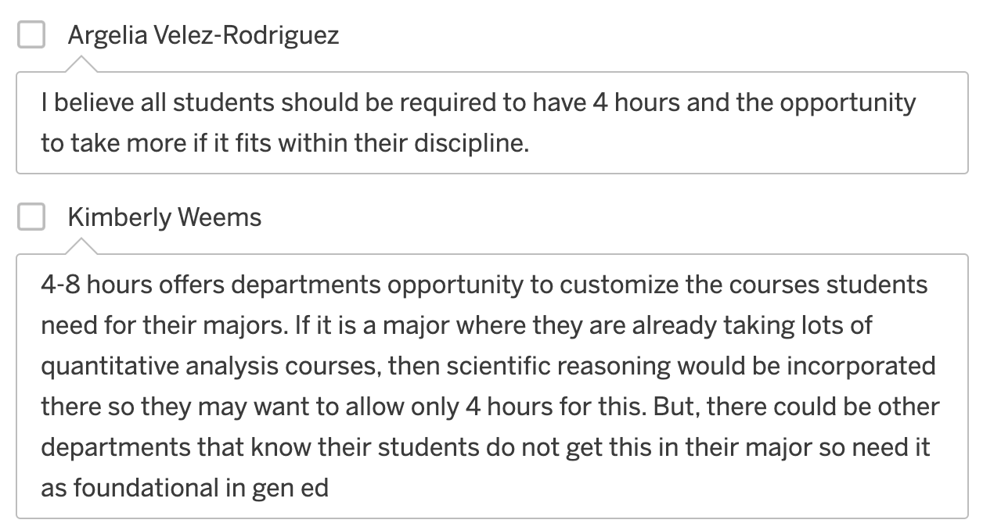
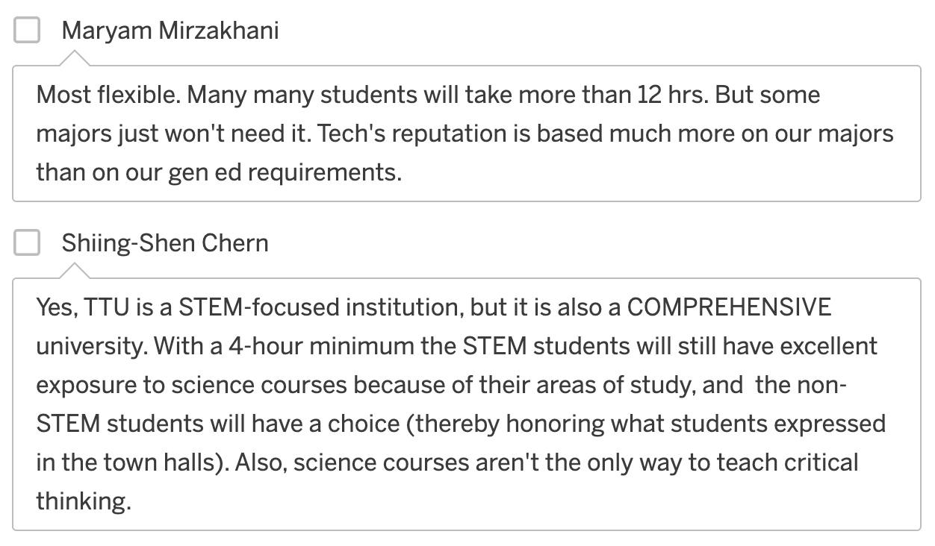

4 to 8 hours

SR Choice Ranking
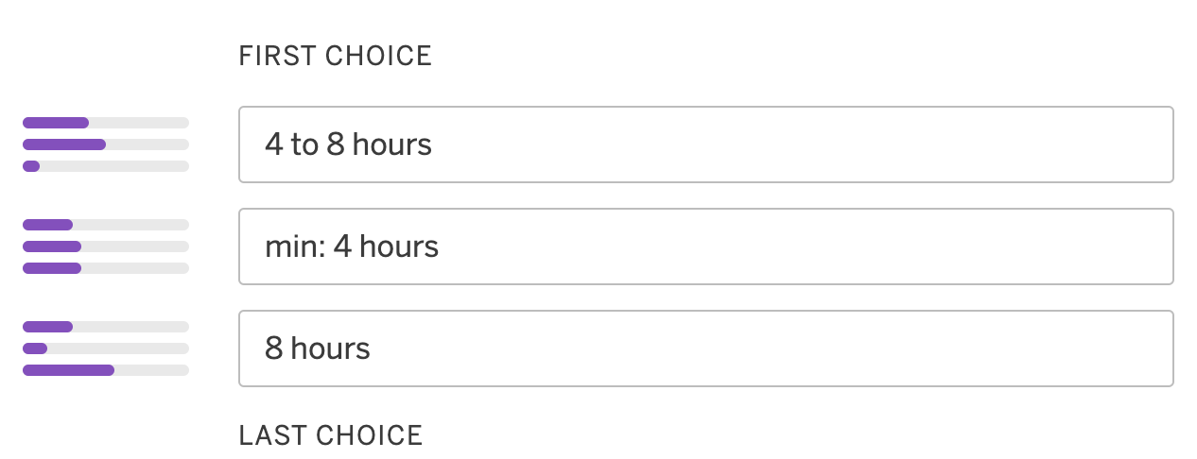

Proposals

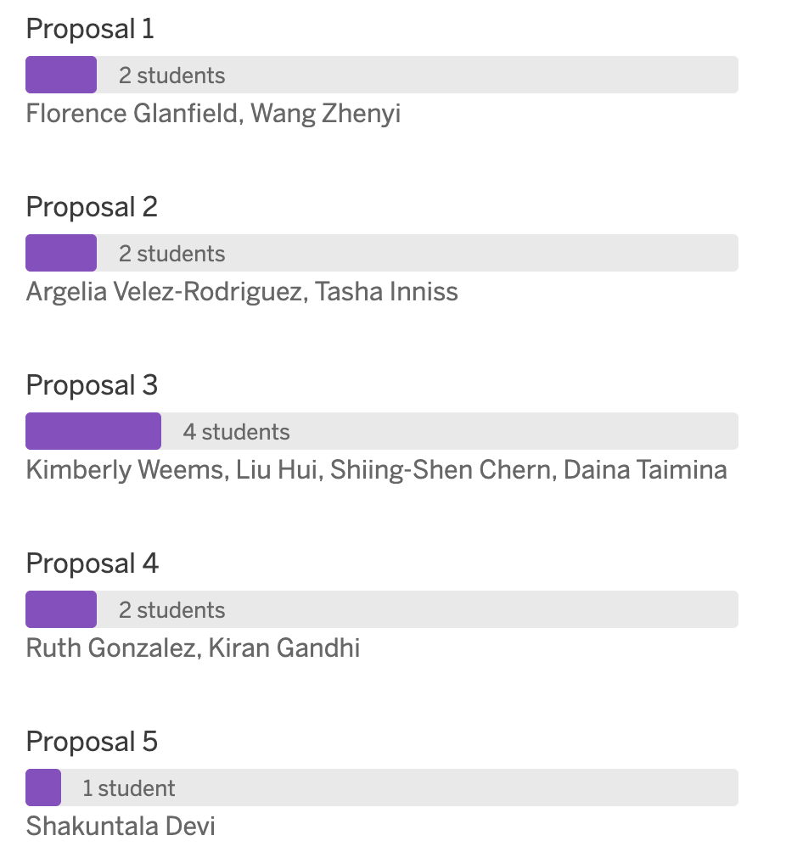
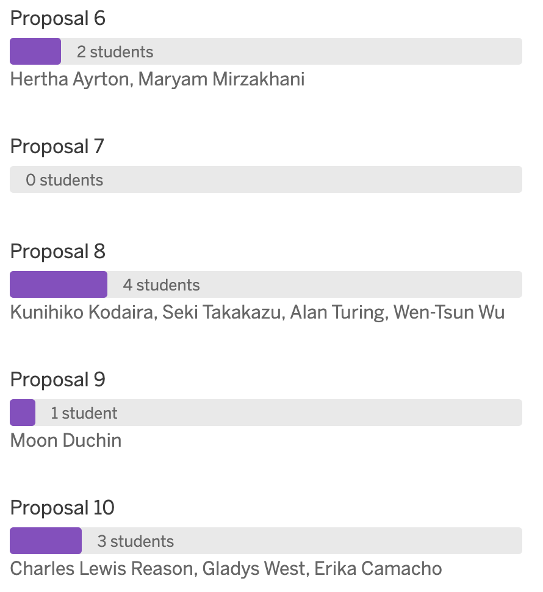

Rationale

Proposal 1
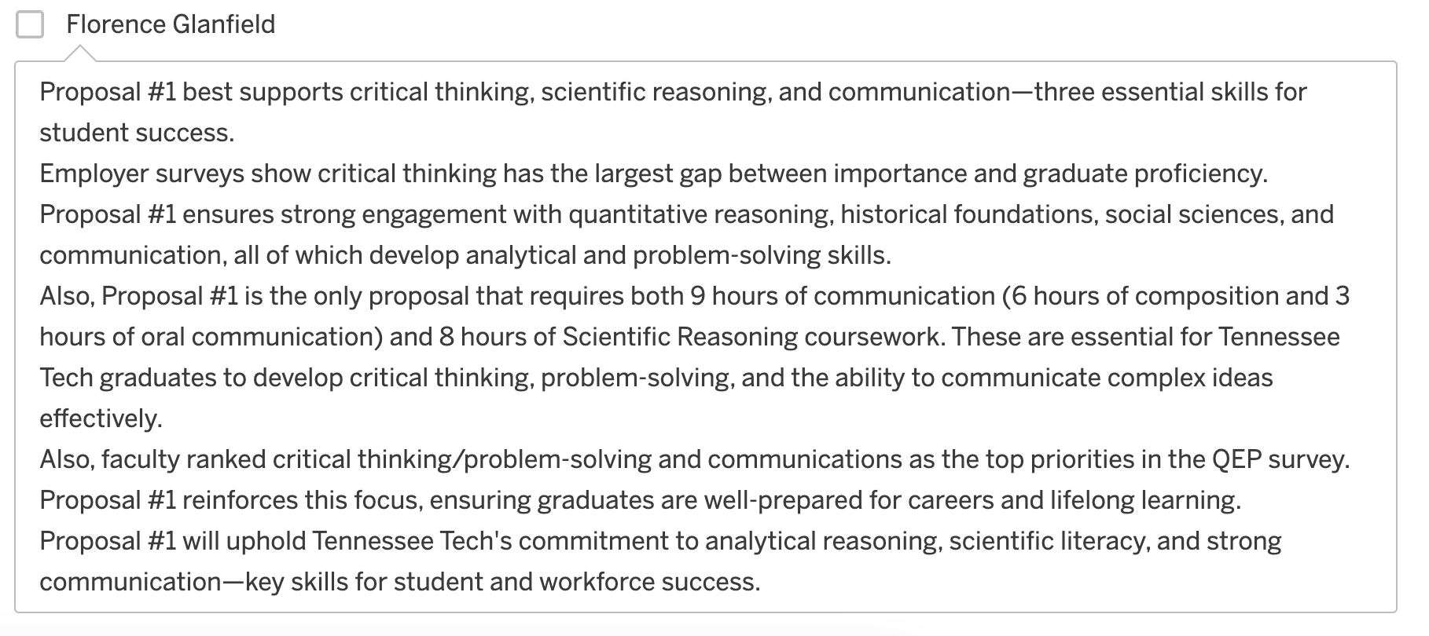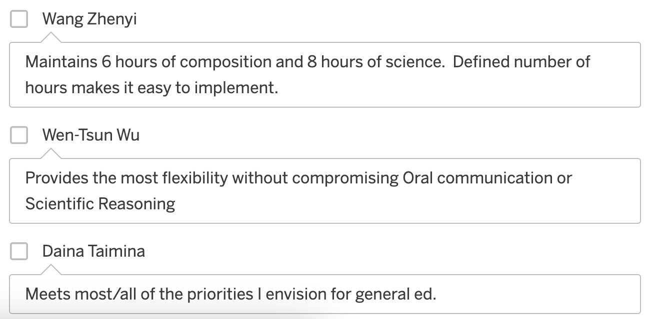

Proposal 2
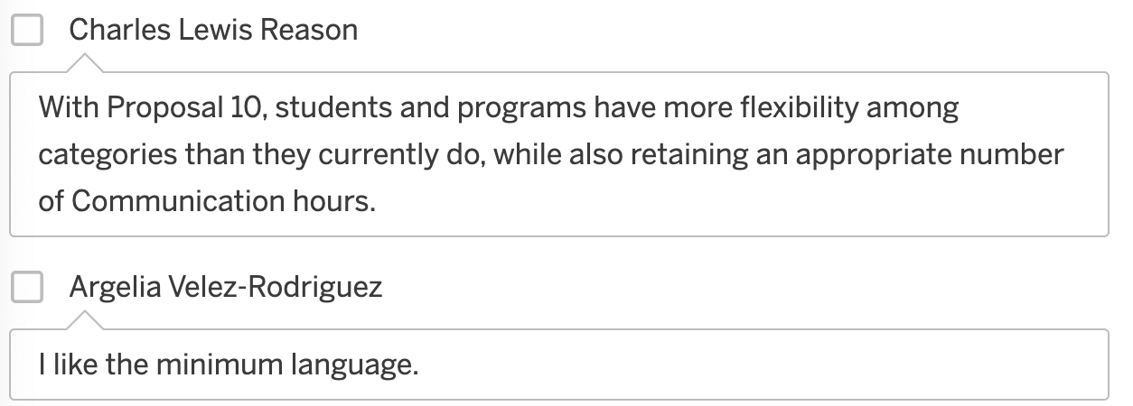

Proposal 3
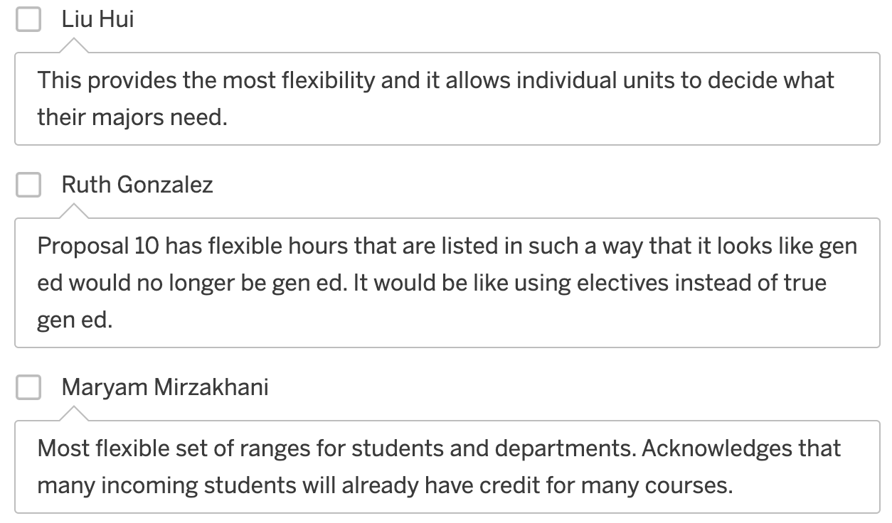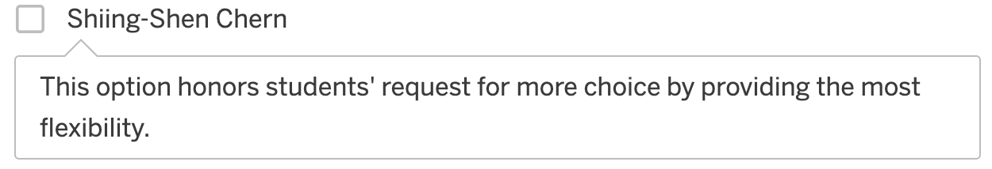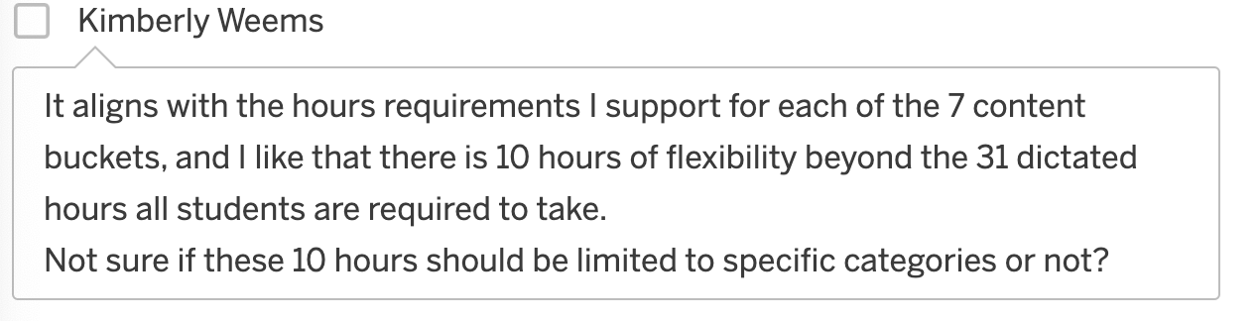

Proposal 4

Proposal 6

Proposal 8

Proposal 10

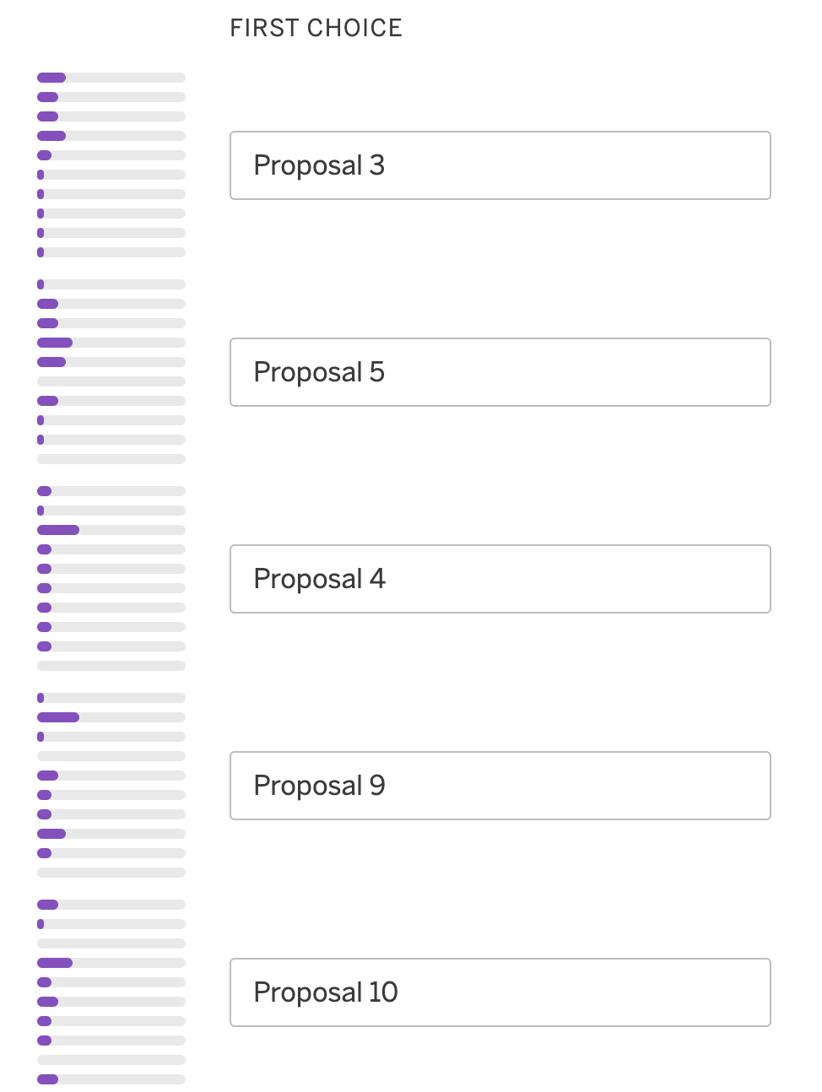
Ranking
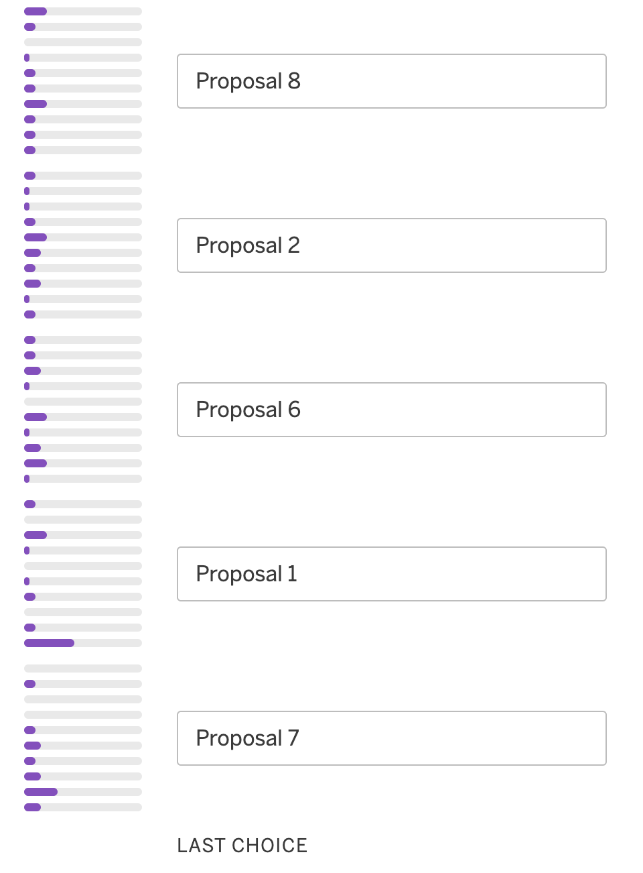

Final Thoughts
