**Gen Ed Survey 2 Voting Summary**

# NOTE: Desmos, the survey system used in this survey, lists all respondents as “students” and anonymizes them by replacing their names with famous mathematicians. Respondents to this survey were exclusively members of the Gen Ed Implementation Committee.

Table of Contents

Quantitative Reasoning & Analysis 2

QRA Choice Rationale 3

3 hours 3

Min: 3 hours 4

QRA Choice Ranking 5

Humanities and Cultural Expression 6

HCE Choice Rationale 7

Min: 6 hours 7

6 to 9 hours 7

HCE Choice Ranking 9

Literature Requirement 10

Literature Req. Rationale 11

Yes 11

No 12

Historical Foundations 14

HiFo Rationale 14

6 hours 14

Min: 3 hours 15

3 to 6 hours 16

HiFo Ranking 17

Social and Behavioral Sciences 17

SBS Rationale 18

6 hours 18

Min: 6 hours 18

SBS Ranking 19

Communication 20

Comm Rationale 20

Min: 6 hours (min: 3 comps; min 3 oral) 20

6 to 9 hours (min: 3 comps; min 3 oral) 21

9 hours (6 comps; 3 oral) 22

9 hours (min: 3 comps; min 3 oral) 22

Comm Ranking 23

Scientific Reasoning 24

SR Rationale 25

8 hours 25

Min: 4 hours 25

4 to 8 hours 26

SR Ranking 26

Financial & Digital Name Preference 27

F&D Rationale 27

Financial & Digital Literacy 27

Financial & Digital Core 28

Other 28

Financial & Digital Preference 29

F&D Preference Rationale 30

Leave Category open for individual program/students to choose from among financial and digital course offerings. 30

Require all students in all majors to take at least 1 credit of financial and 1 credit of digital 30

Financial & Digital Category 31

F&D Rationale 31

3 hours 31

Min: 3 hours 32

3 to 4 hours 32

3 to 6 hours 32

F&D Ranking 33

Voting 34

Voting Rationale 35

Voice Vote 35

Show of Hands 35

Ballot voting 35

Ranked Choice Voting 35

Each Subcommittee Rank their top Two Choices 35

Proposals 36

Proposals Rationale 37

Proposal 2 37

Proposal 3 37

Proposal 9 38

Proposal 11 38

Proposal Ranking 39

Final Thoughts 40

# Quantitative Reasoning & Analysis

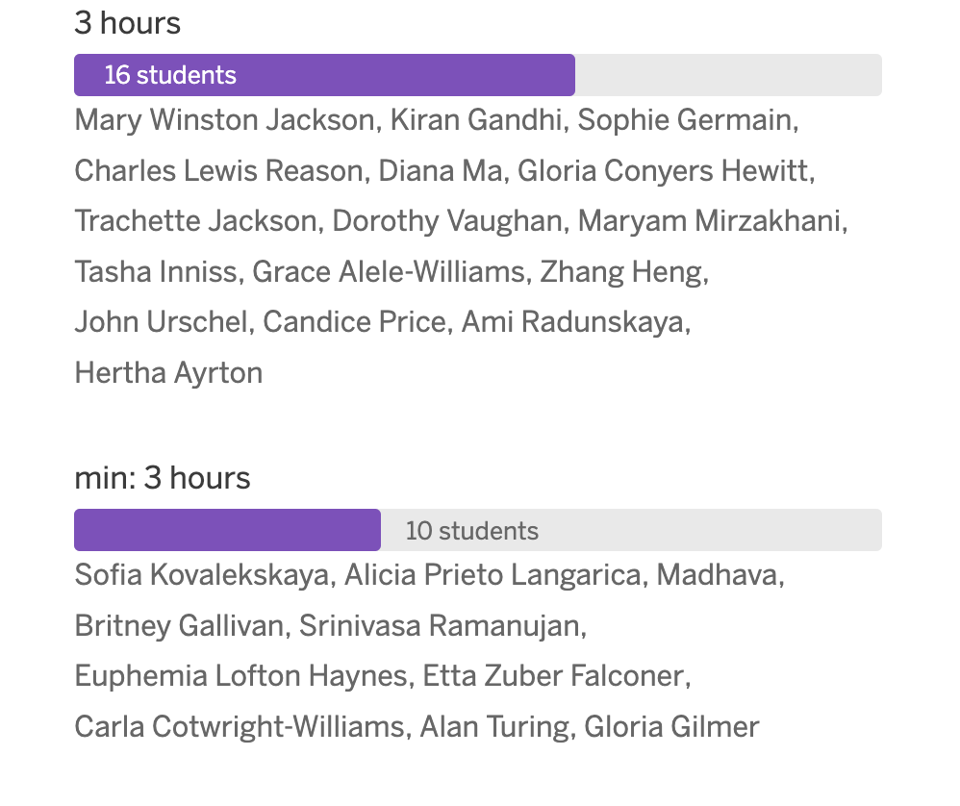

## QRA Choice Rationale

### 3 hours

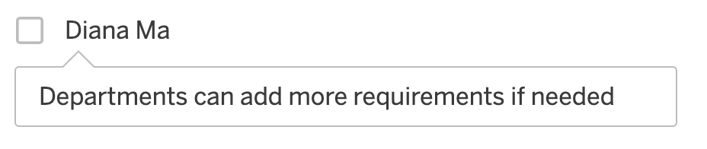

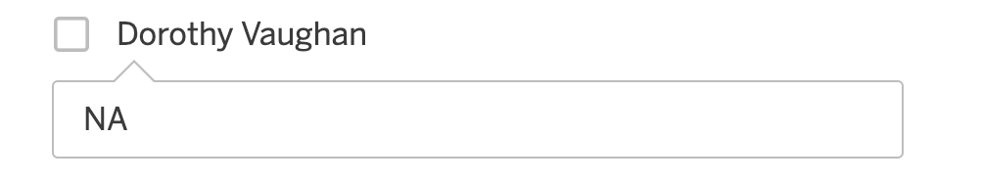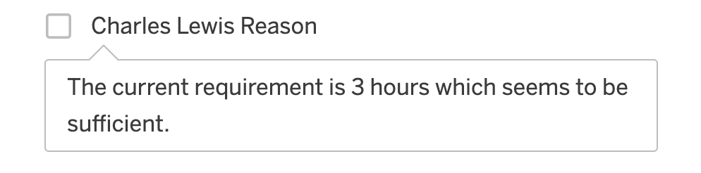

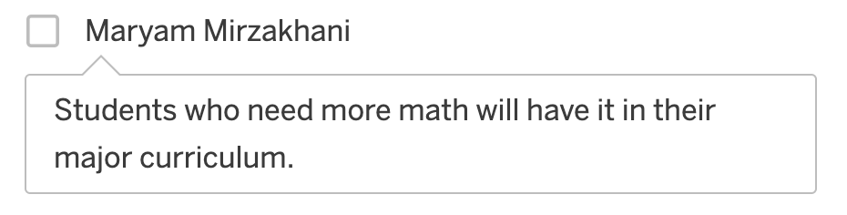

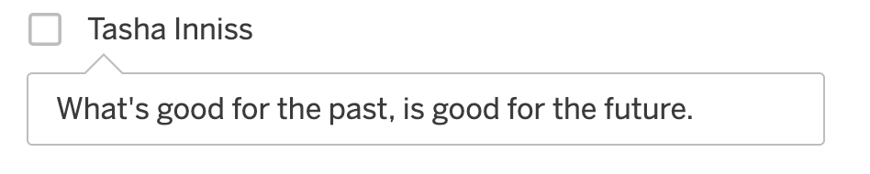

### Min: 3 hours

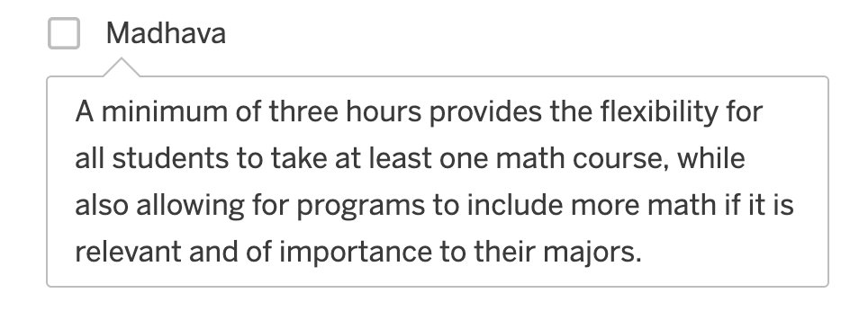

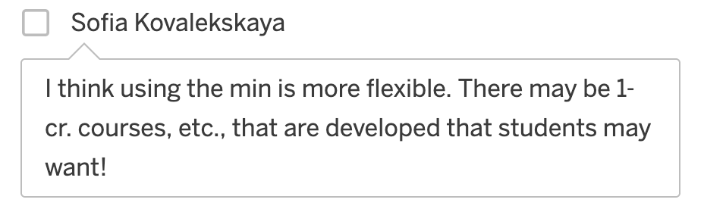

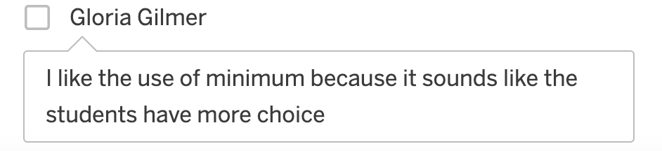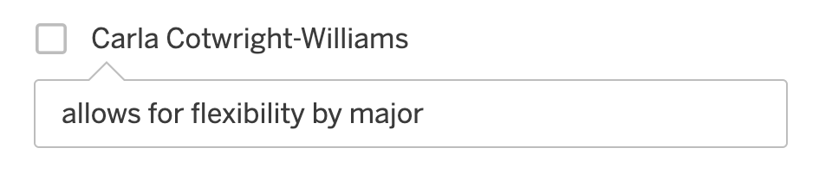

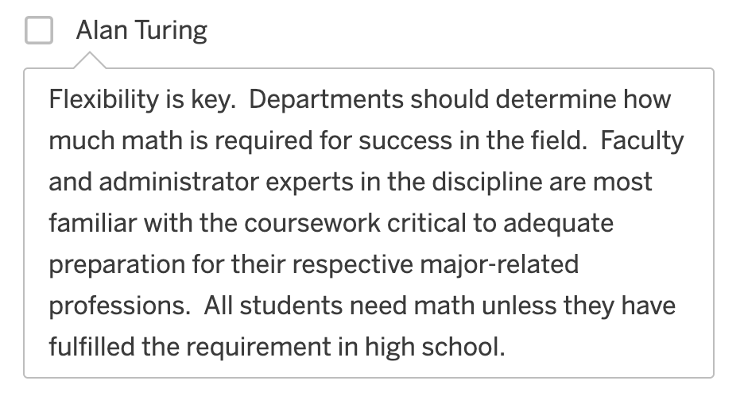

# Humanities and Cultural Expression

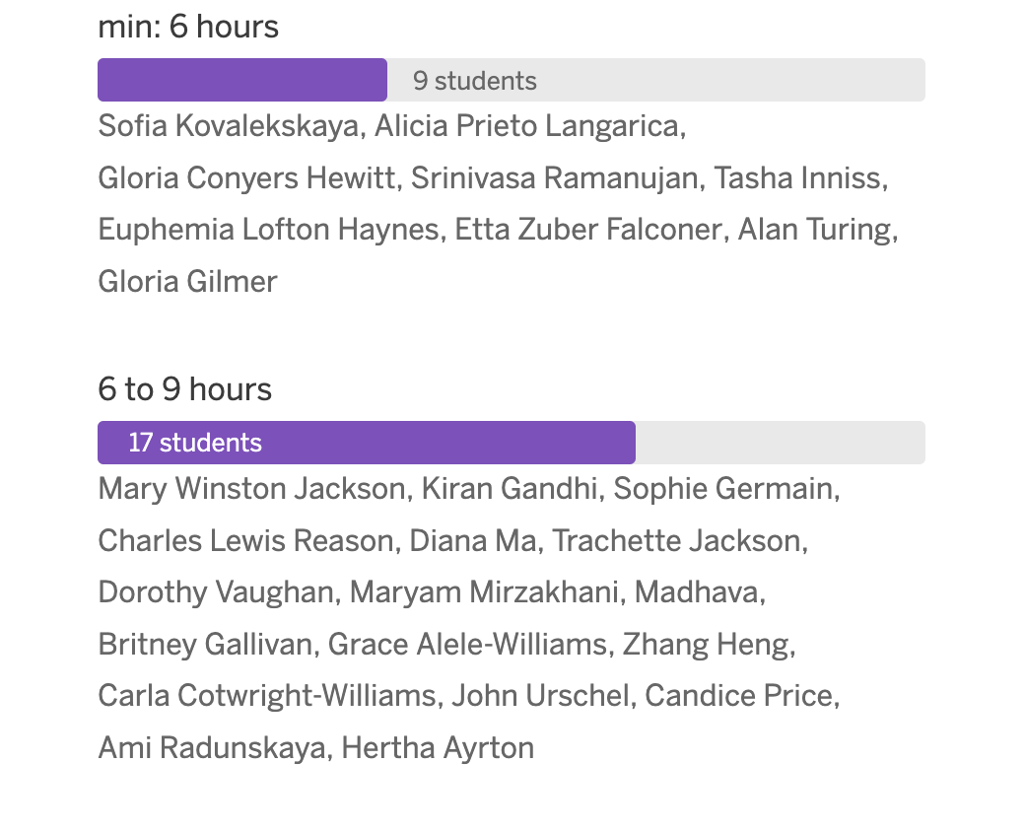

## HCE Choice Rationale

### Min: 6 hours

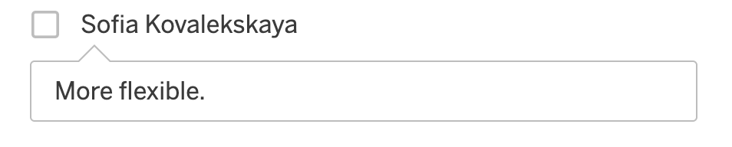

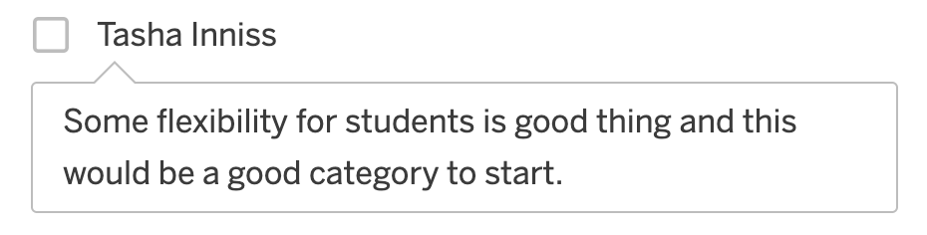

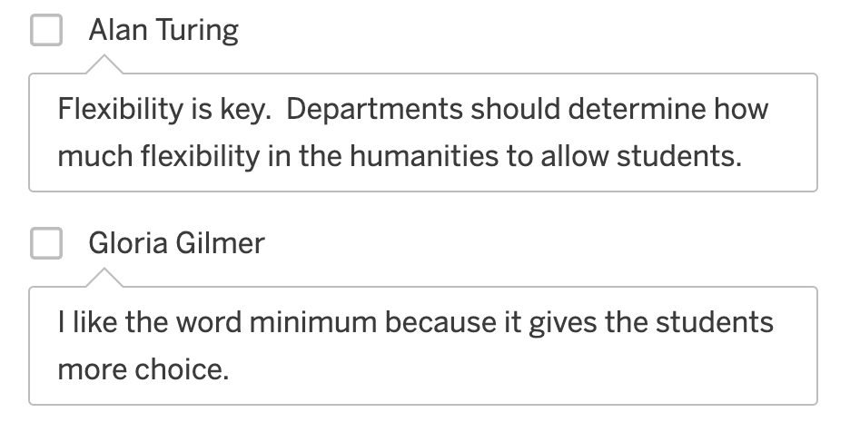

### 6 to 9 hours

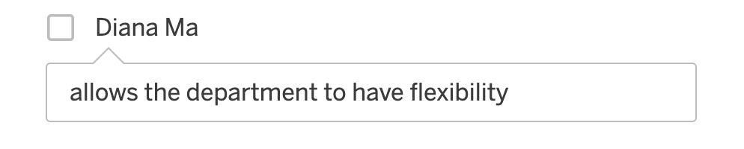

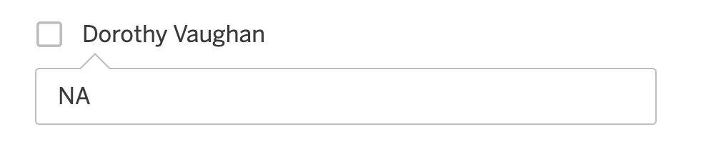

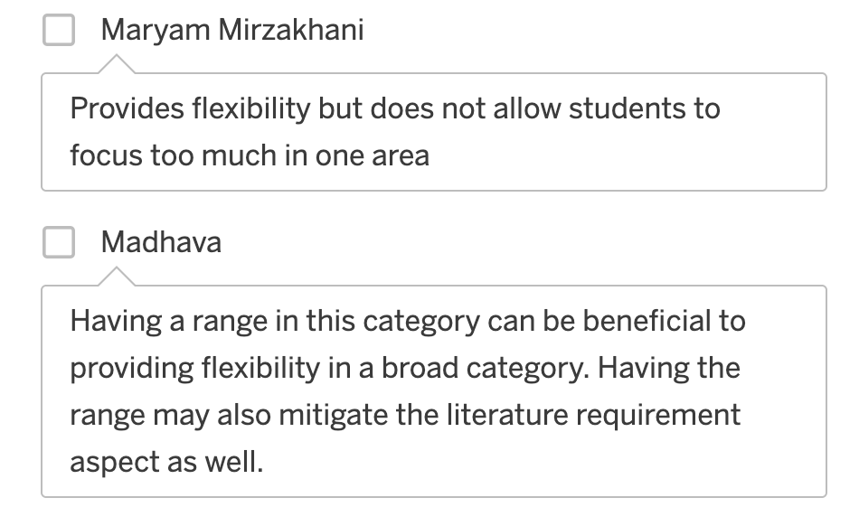

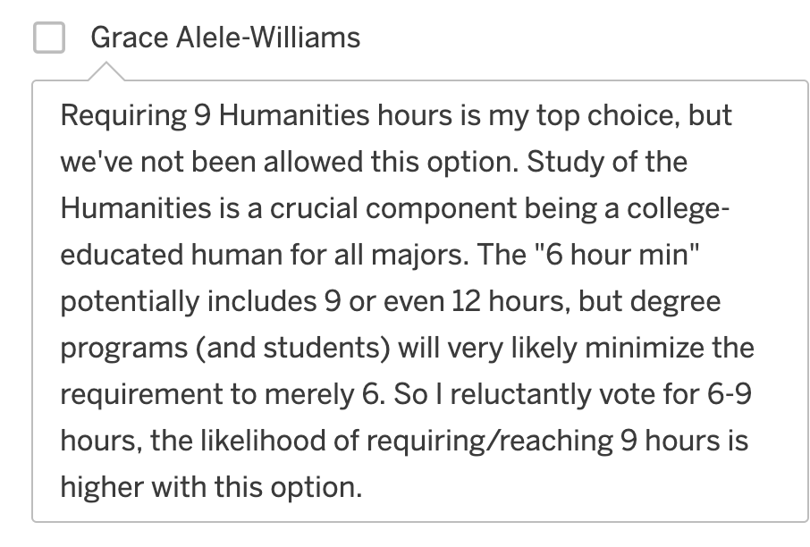

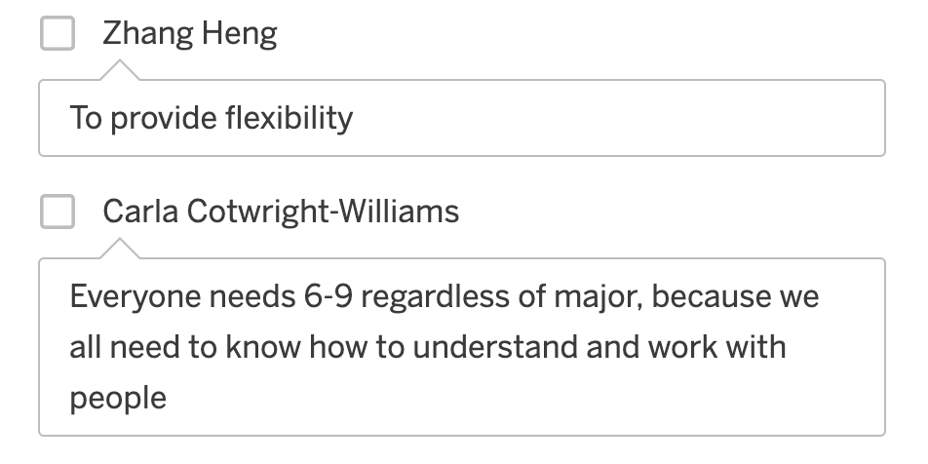

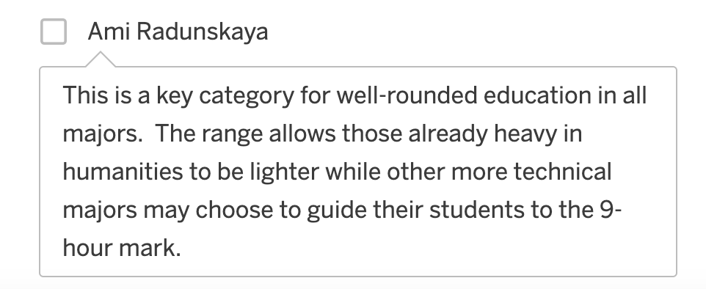

# Literature Requirement

Do you think we should require all students in all majors to take a literature course within the Humanities & Cultural Expression Category?

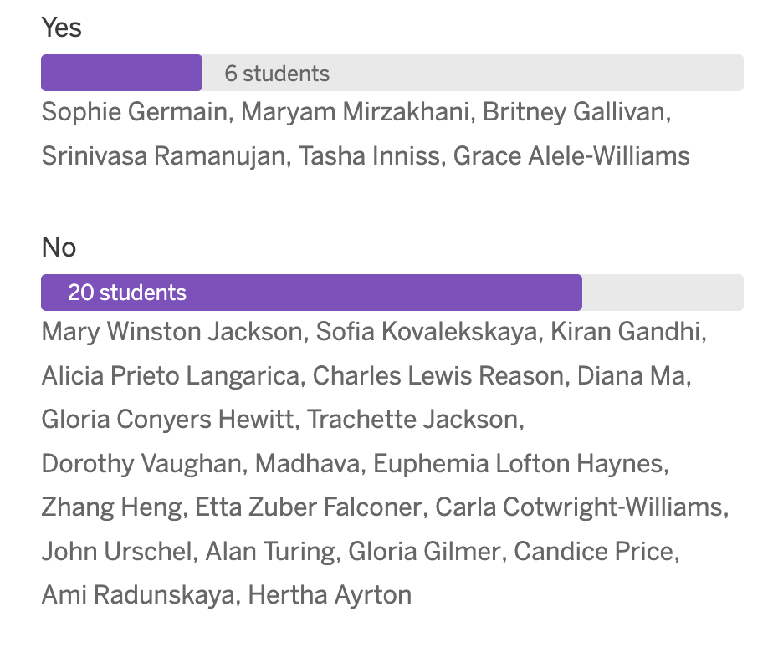

## Literature Req. Rationale

### Yes

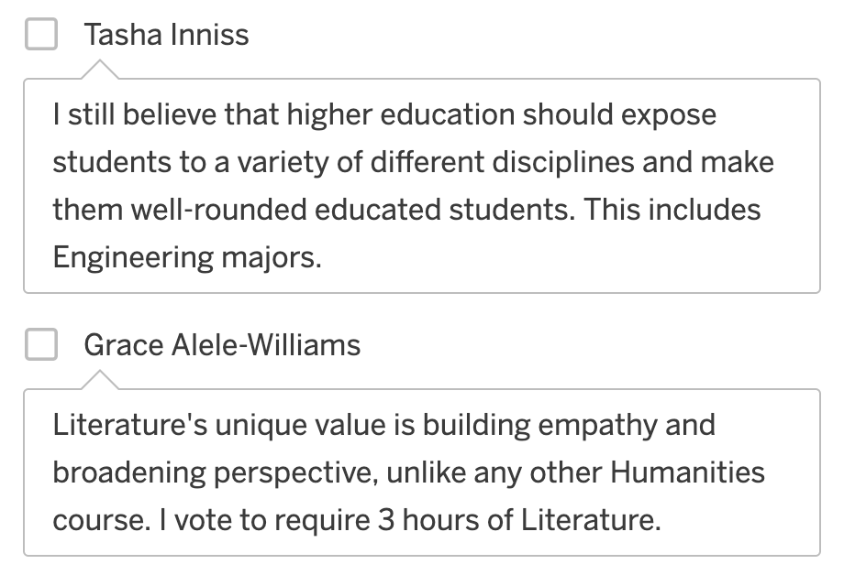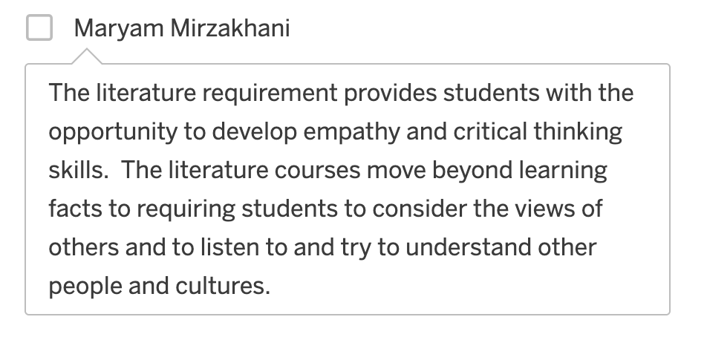

### No

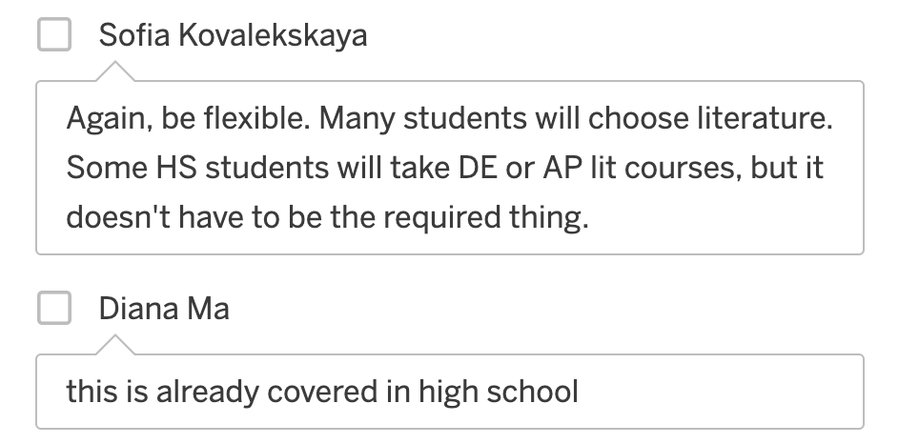

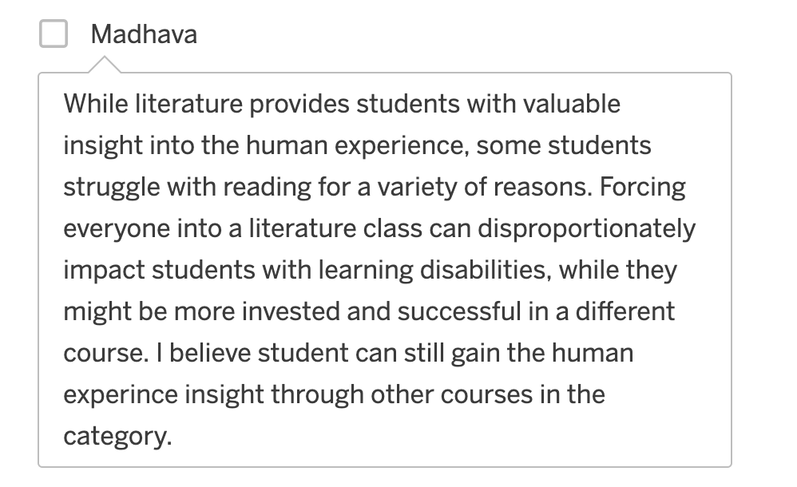

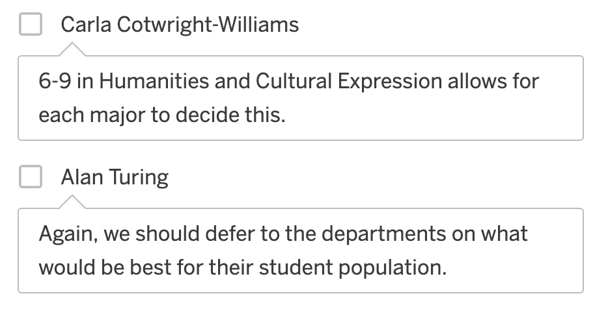

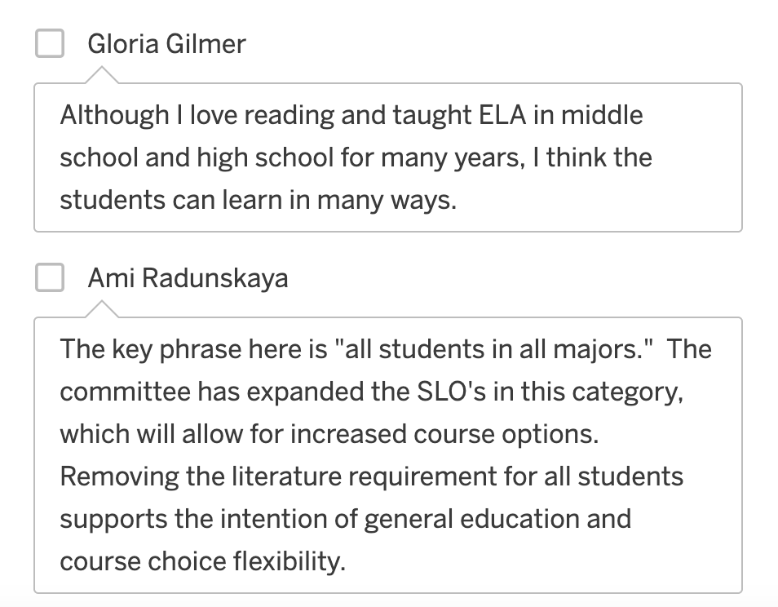

# Historical Foundations

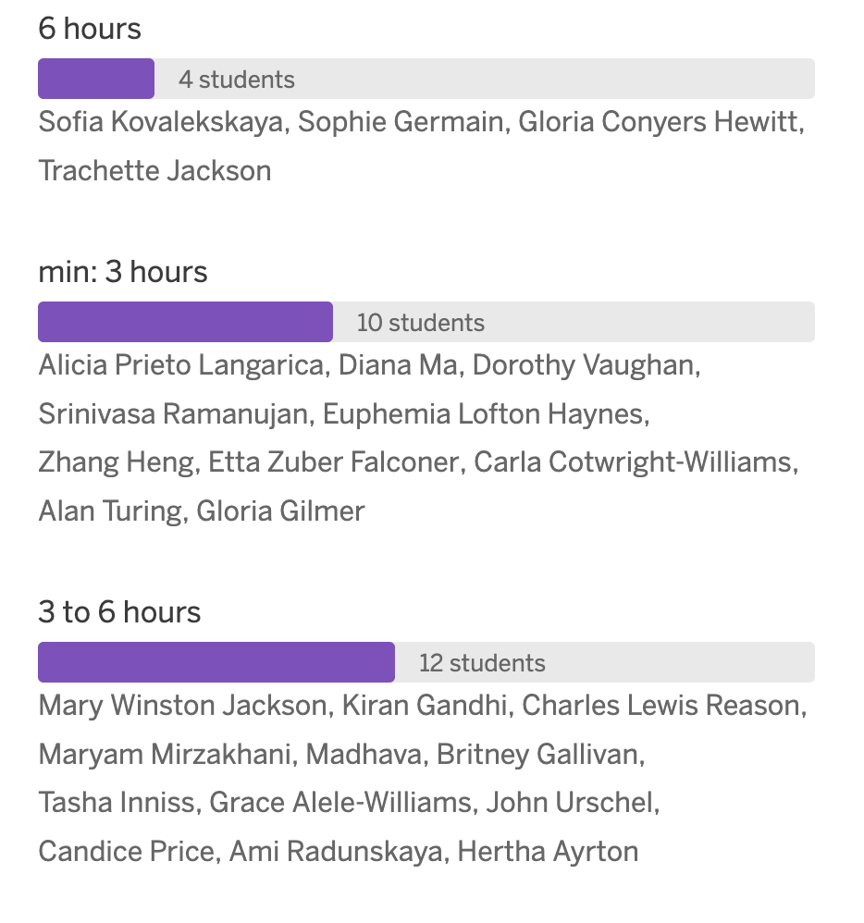

## HiFo Rationale

### 6 hours

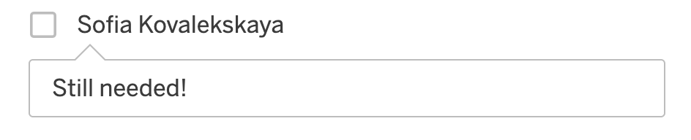

### Min: 3 hours

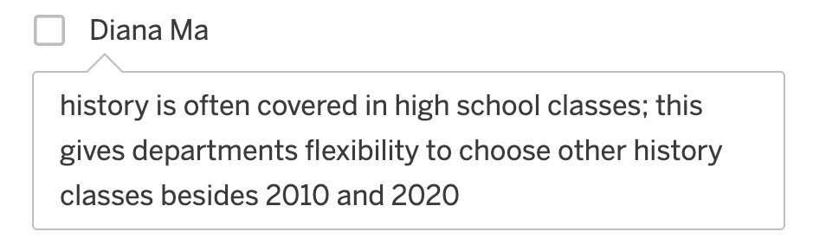

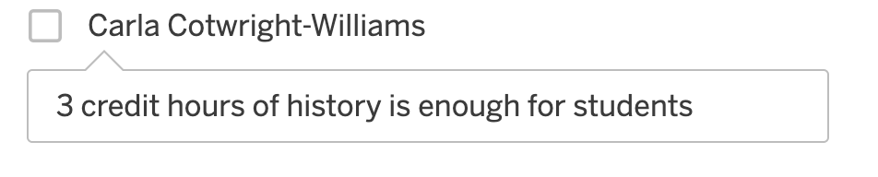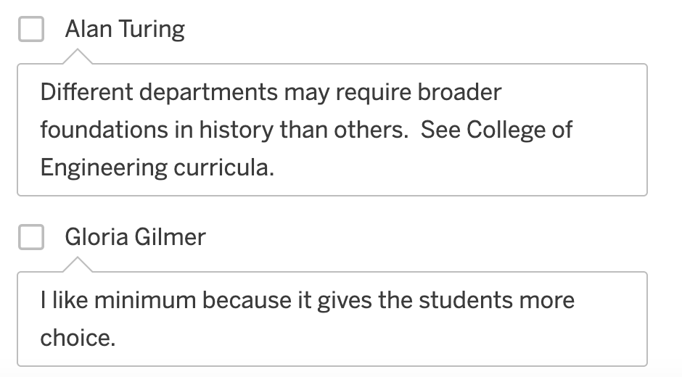

### 3 to 6 hours

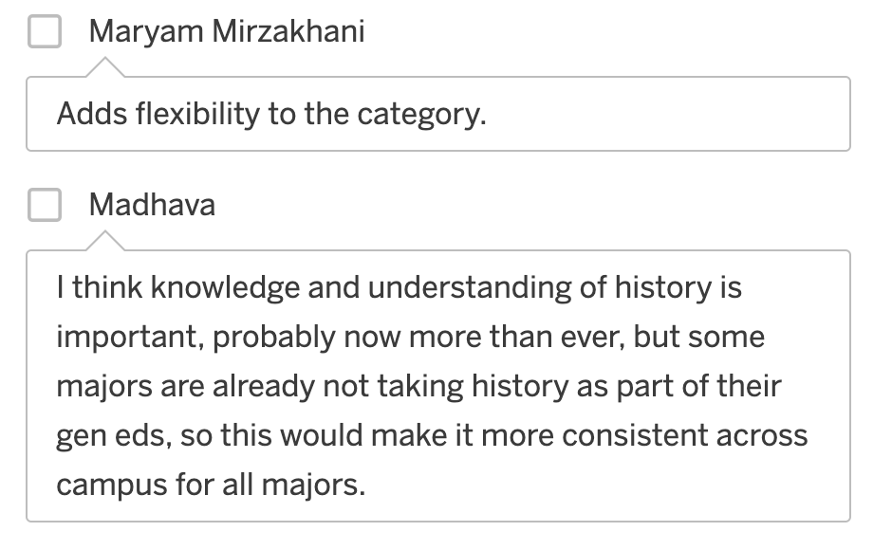

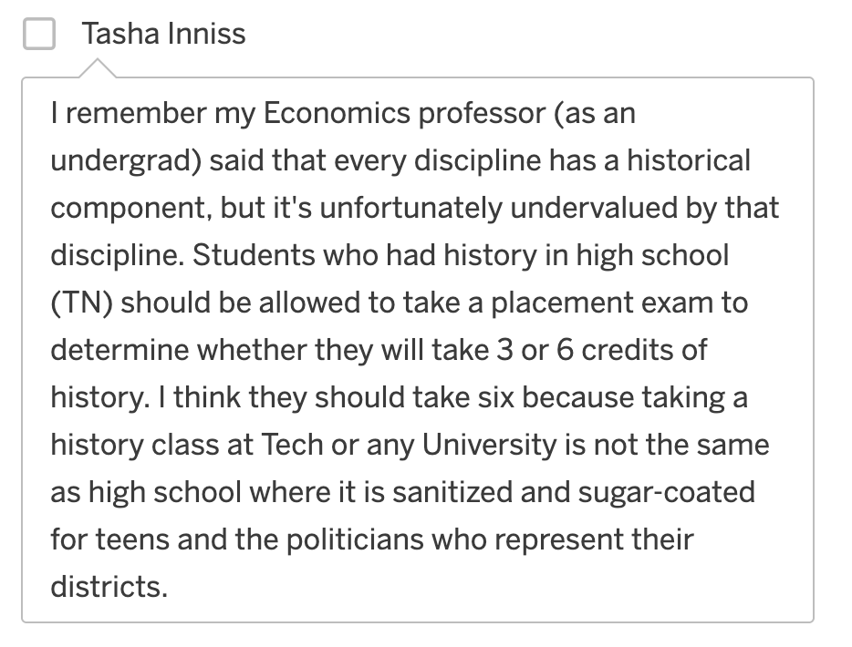

## HiFo Ranking

# Social and Behavioral Sciences

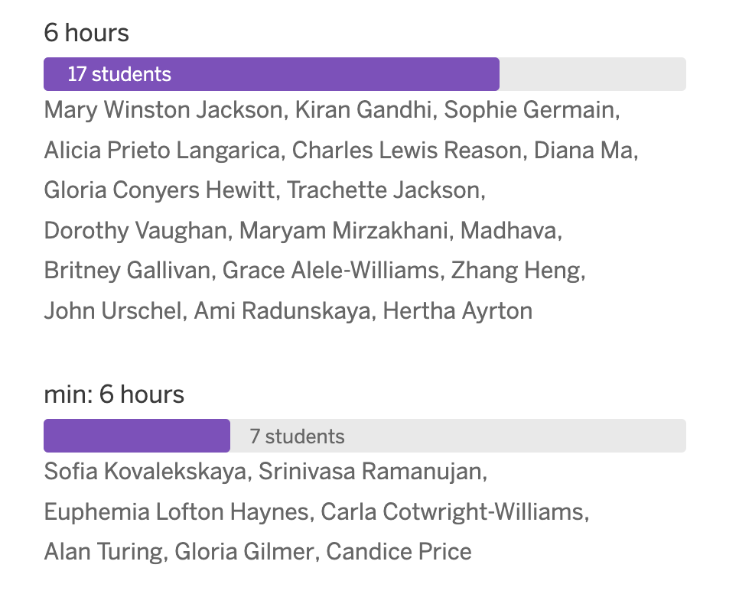

## SBS Rationale

### 6 hours

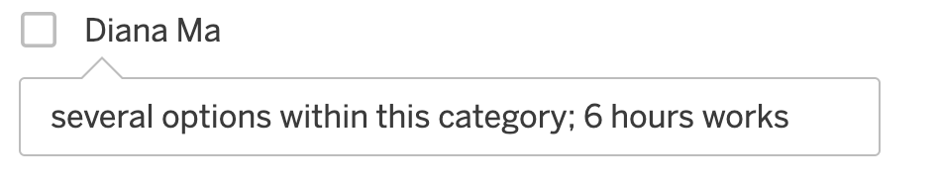

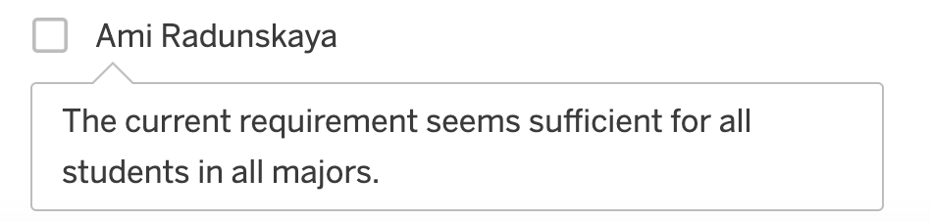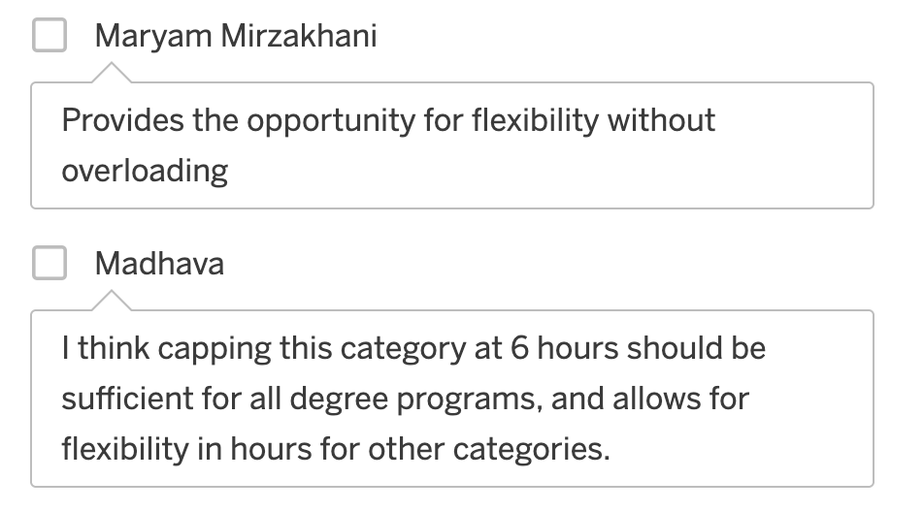

### Min: 6 hours

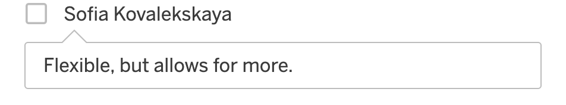

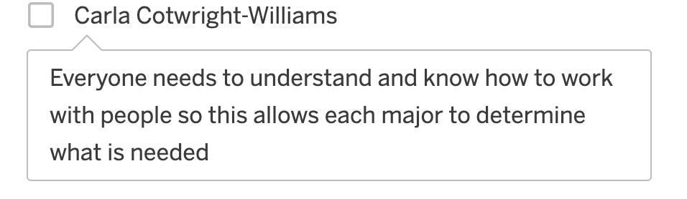

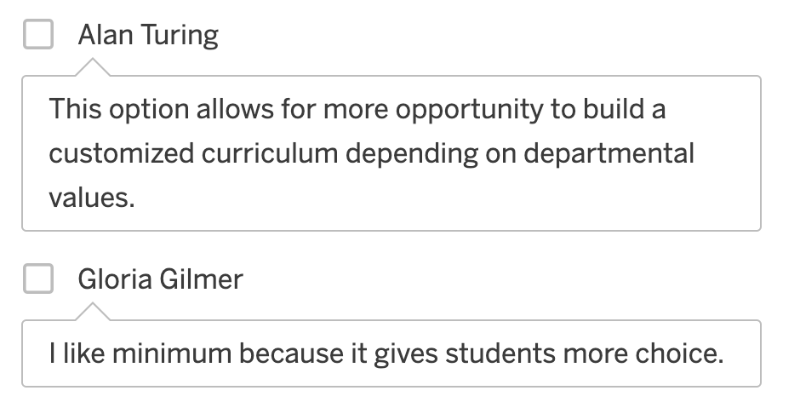

# Communication

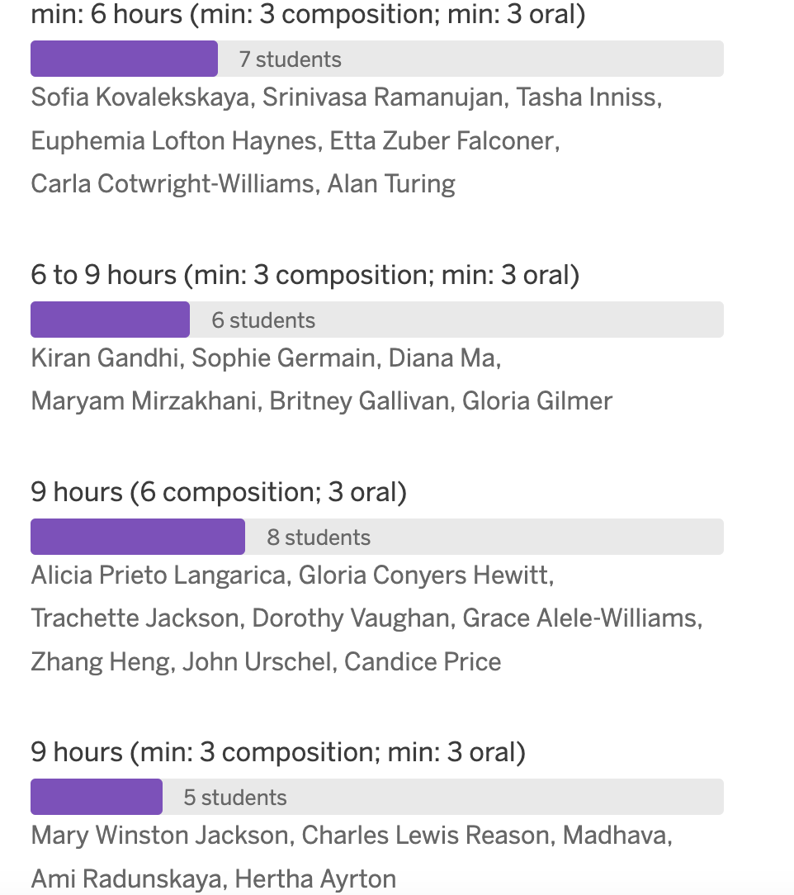

## Comm Rationale

### Min: 6 hours (min: 3 comps; min 3 oral)

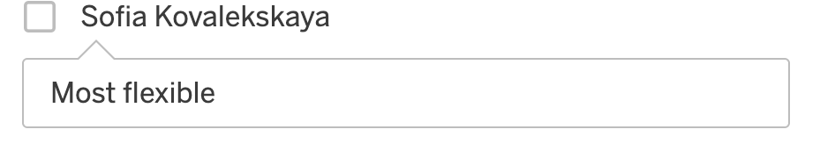

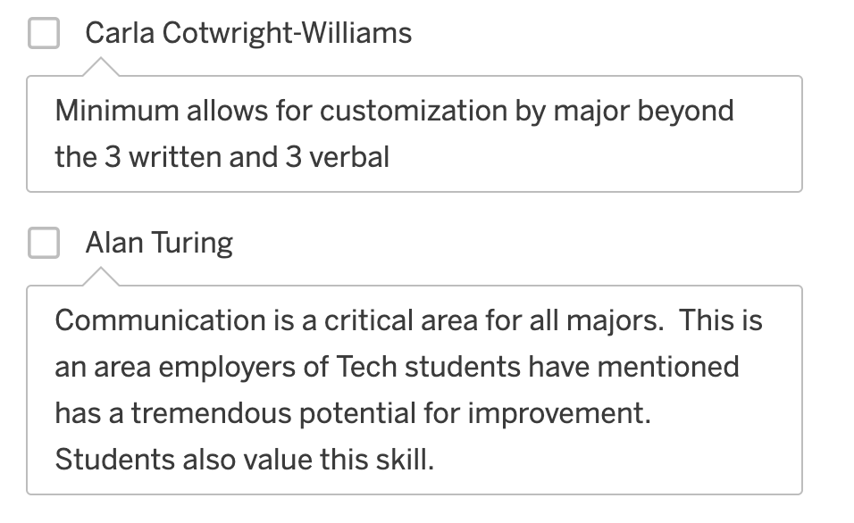

### 6 to 9 hours (min: 3 comps; min 3 oral)

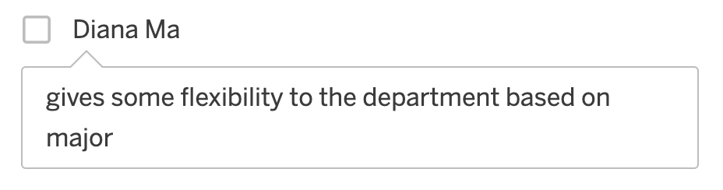

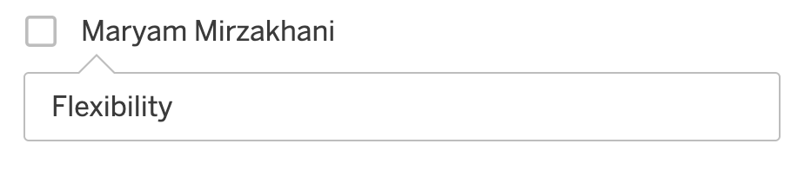

### 9 hours (6 comps; 3 oral)

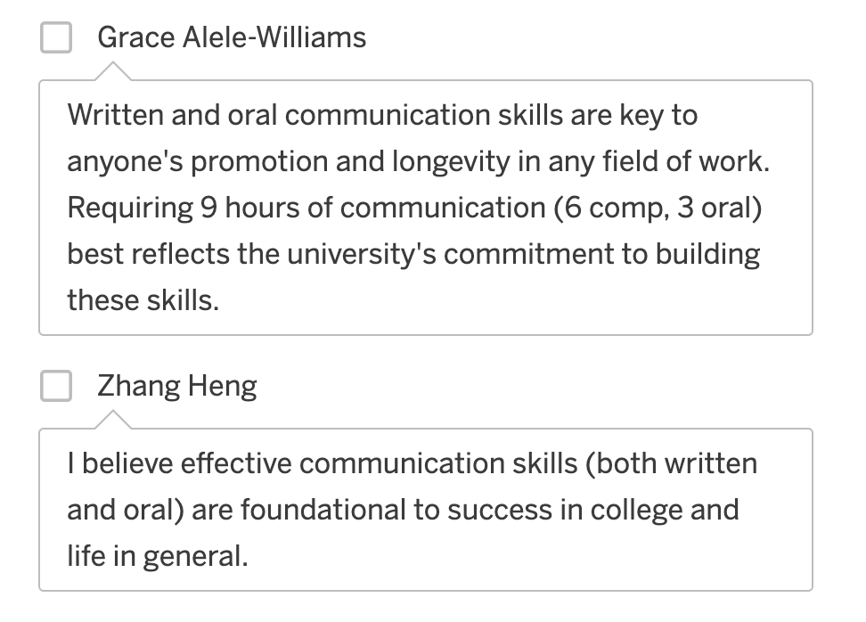

### 9 hours (min: 3 comps; min 3 oral)

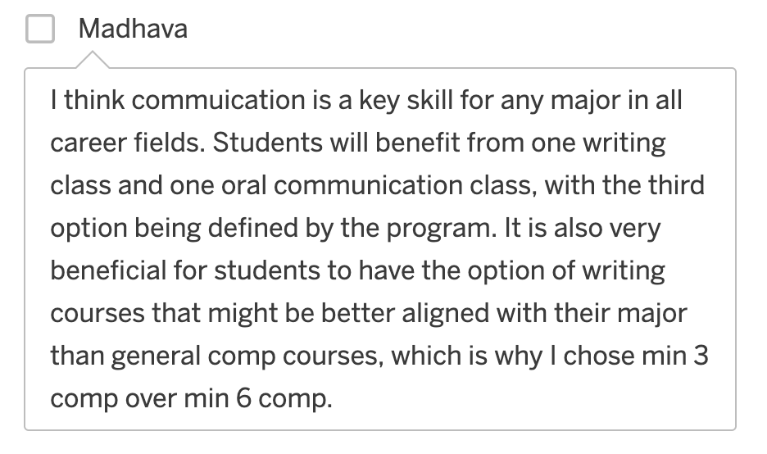

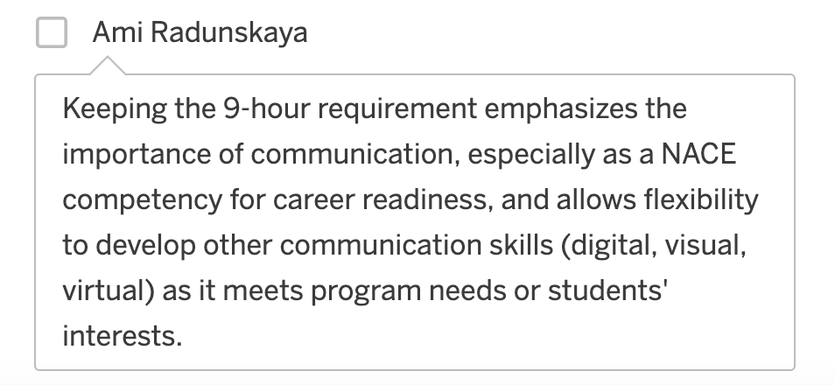

# Scientific Reasoning

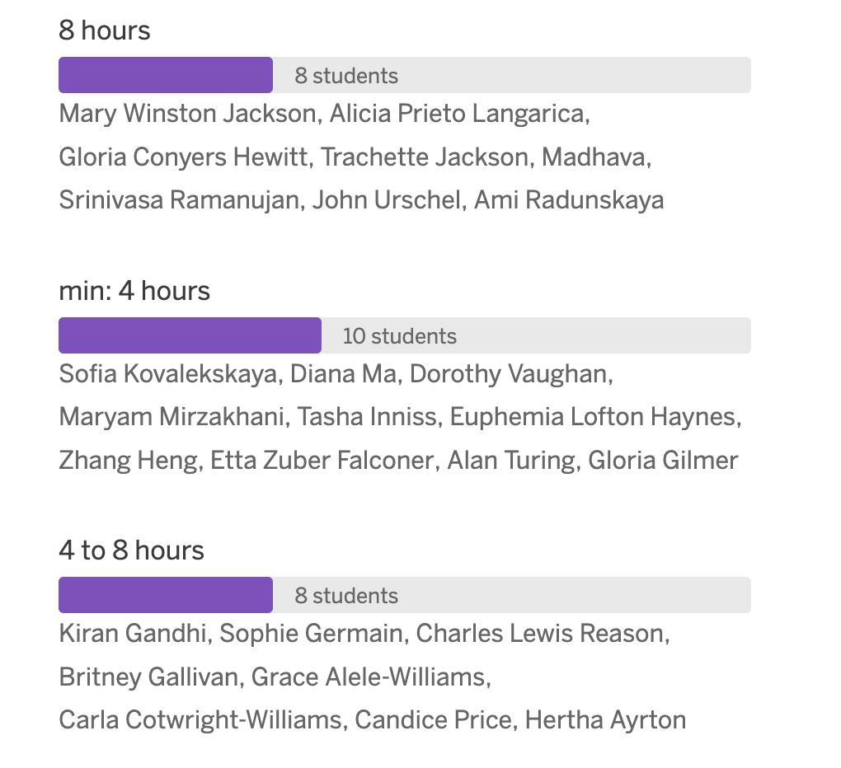

## SR Rationale

### 8 hours

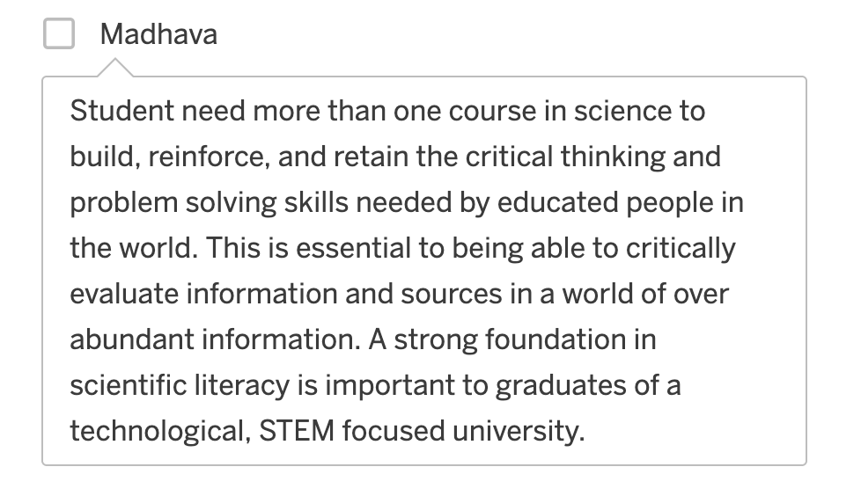

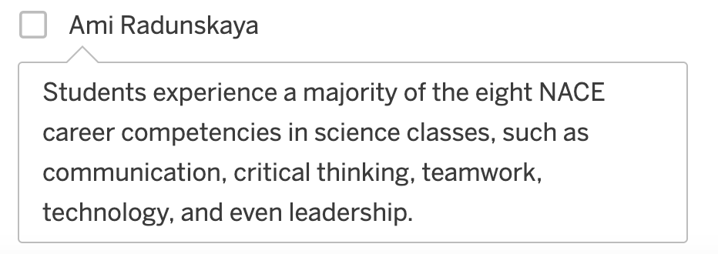

### Min: 4 hours

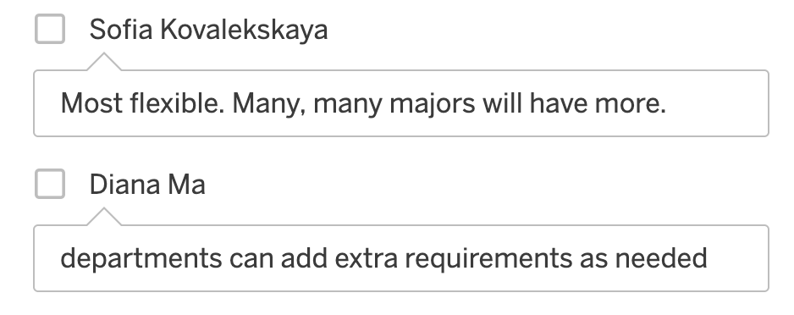

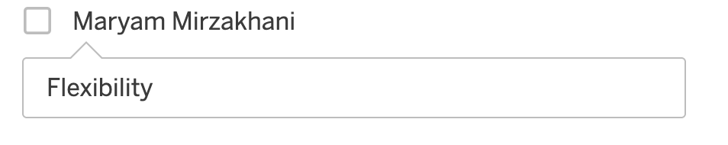

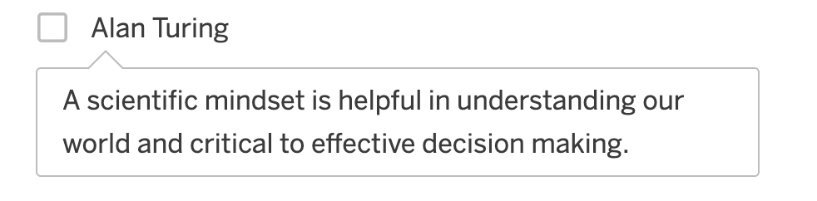

### 4 to 8 hours

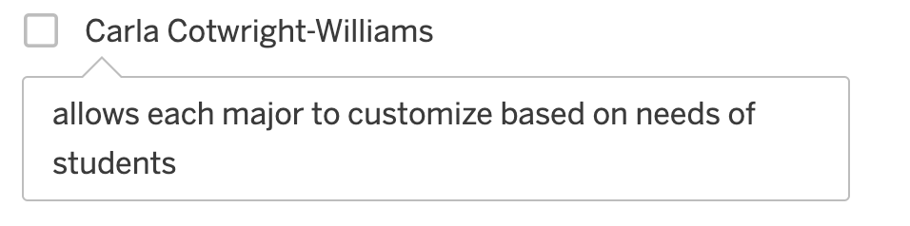

# Financial & Digital Name Preference

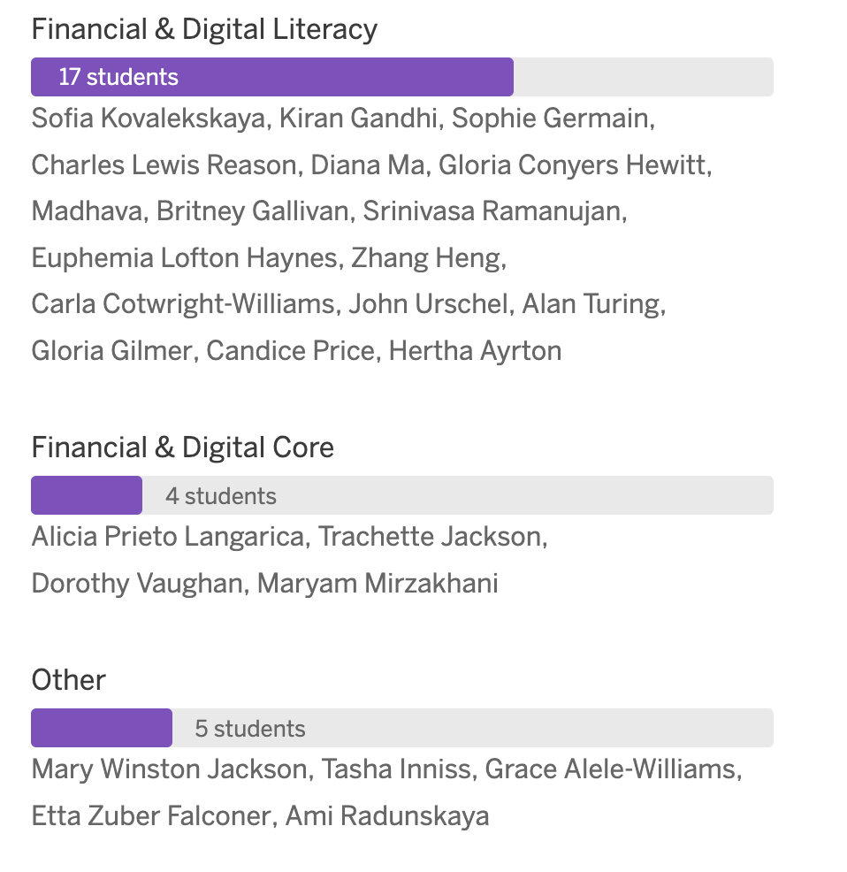

## F&D Rationale

### Financial & Digital Literacy

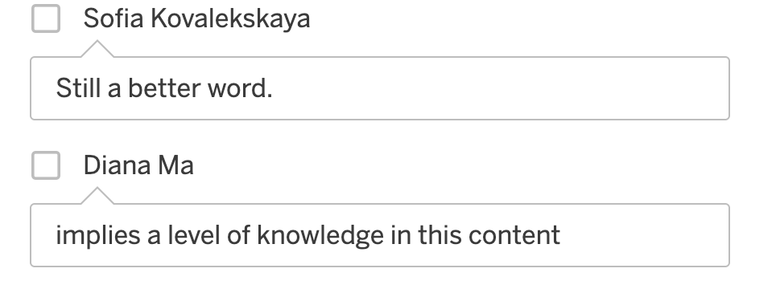

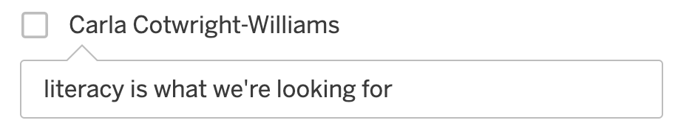

### Financial & Digital Core

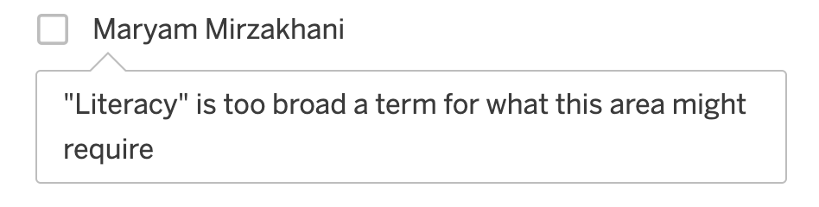

### Other

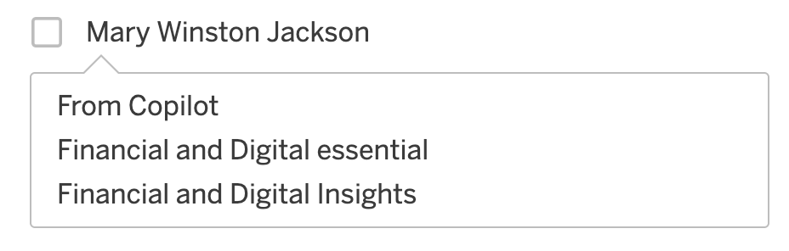

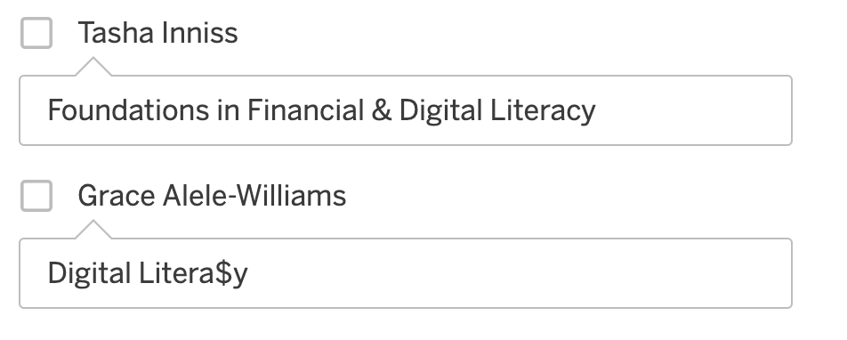

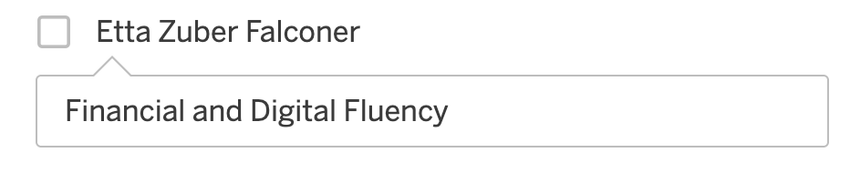

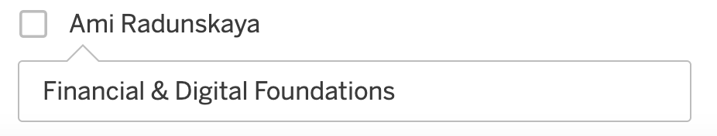

# Financial & Digital Preference

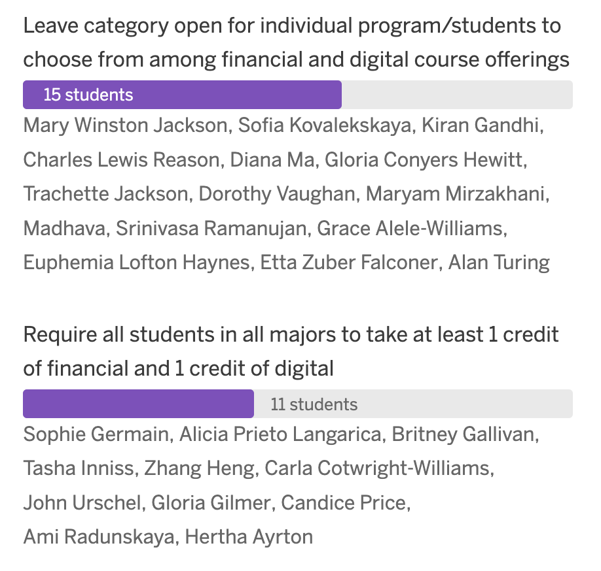

## F&D Preference Rationale

### Leave Category open for individual program/students to choose from among financial and digital course offerings.

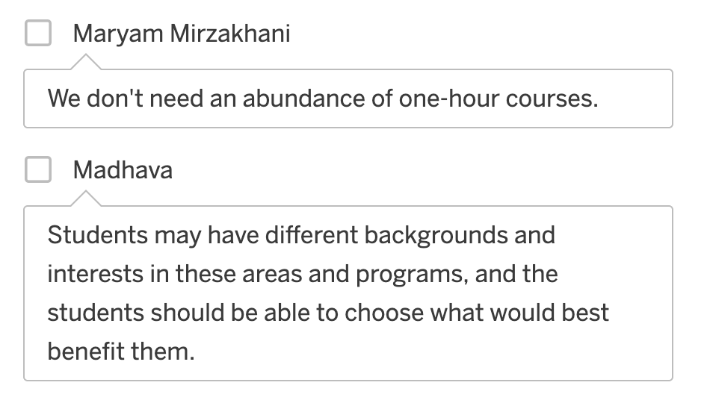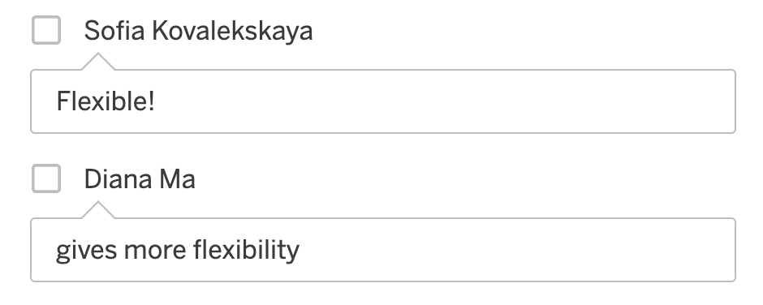

### Require all students in all majors to take at least 1 credit of financial and 1 credit of digital

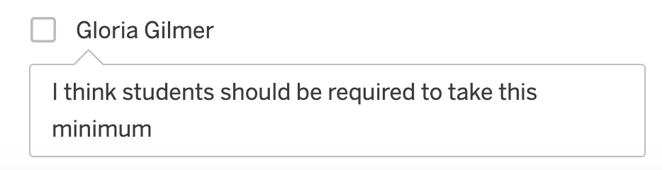

# Financial & Digital Category

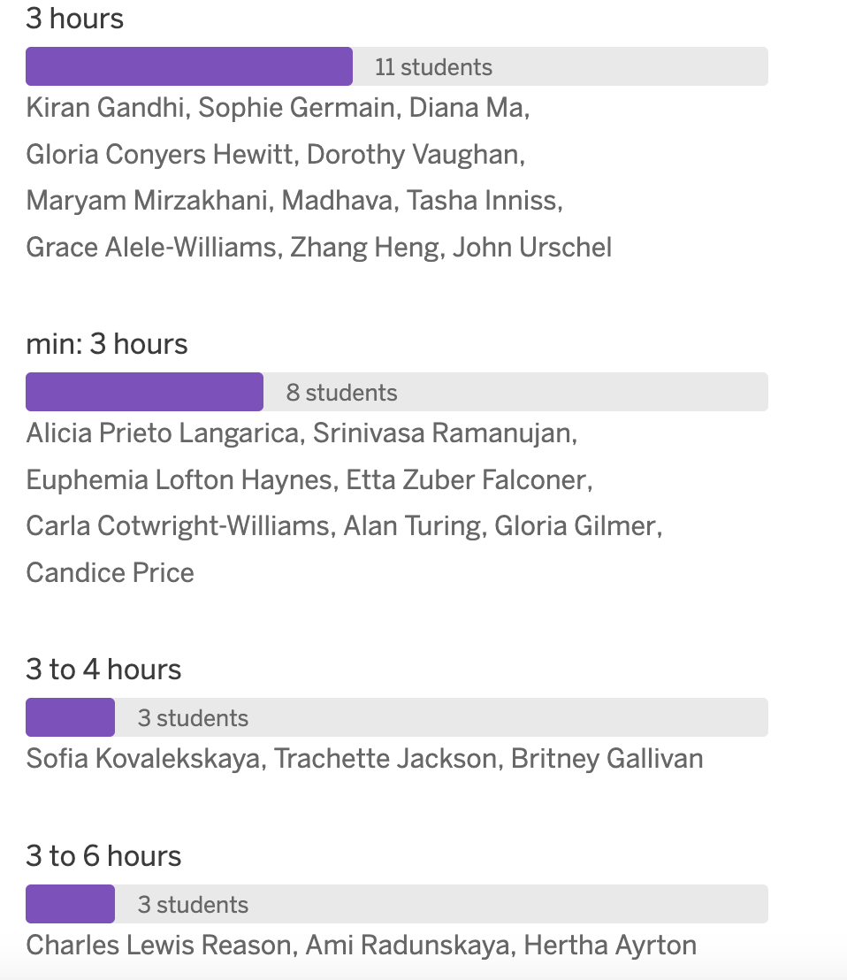

## F&D Rationale

### 3 hours

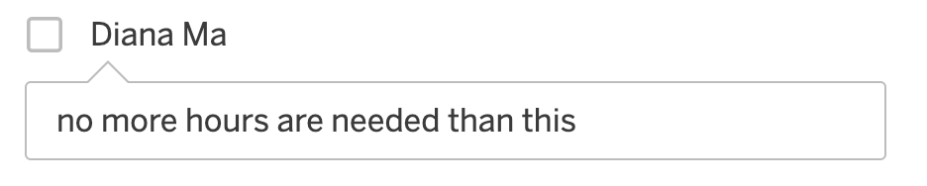

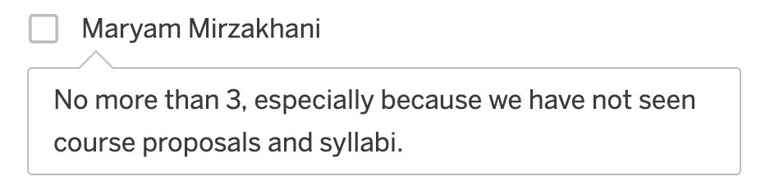

### Min: 3 hours

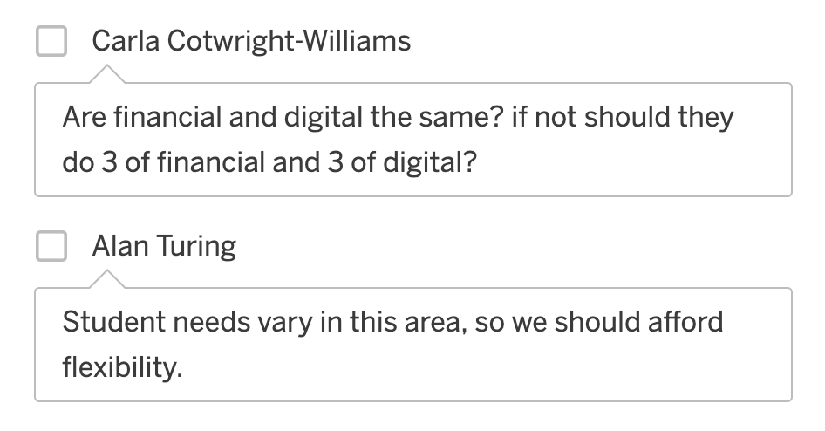

### 3 to 4 hours

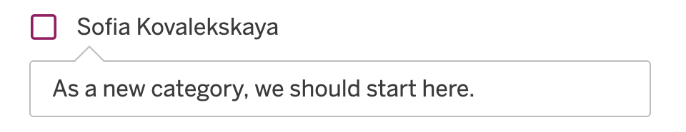

### 3 to 6 hours

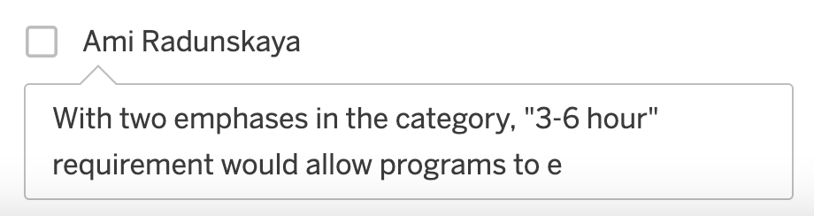

# Voting

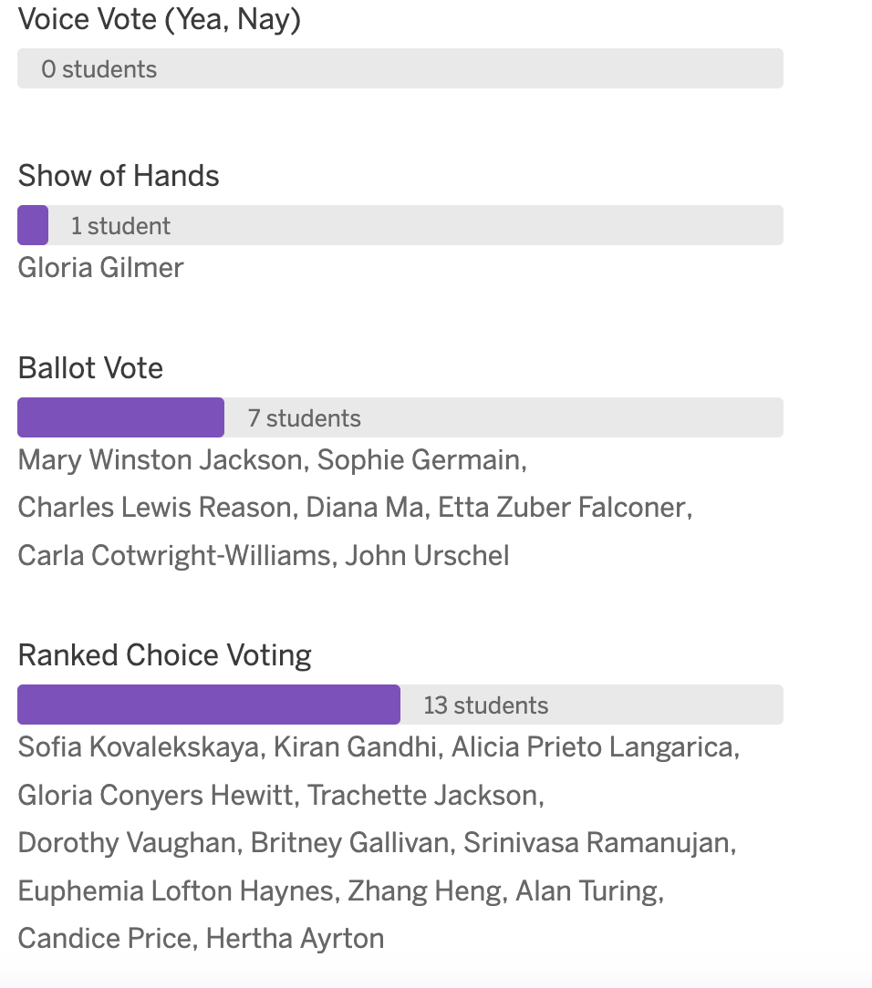

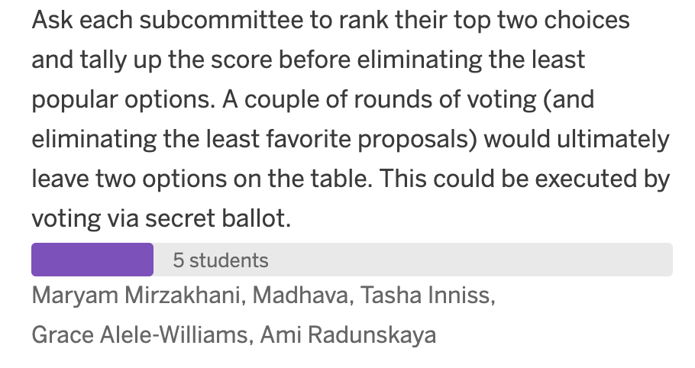

## Voting Rationale

### Voice Vote

No rationale given

### Show of Hands

No rationale given

### Ballot voting

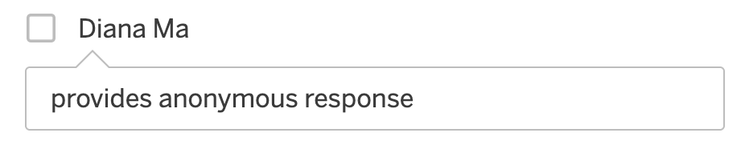

### Ranked Choice Voting

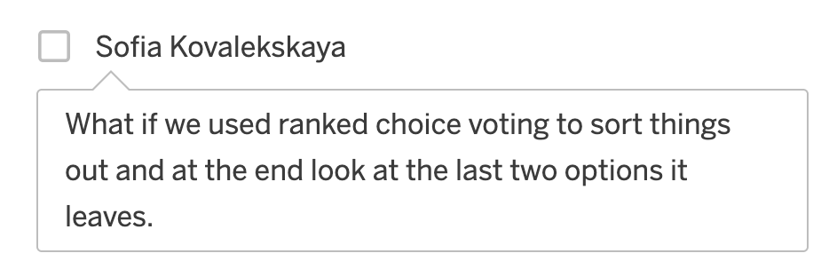

### Each Subcommittee Rank their top Two Choices

No rational given

# Proposals

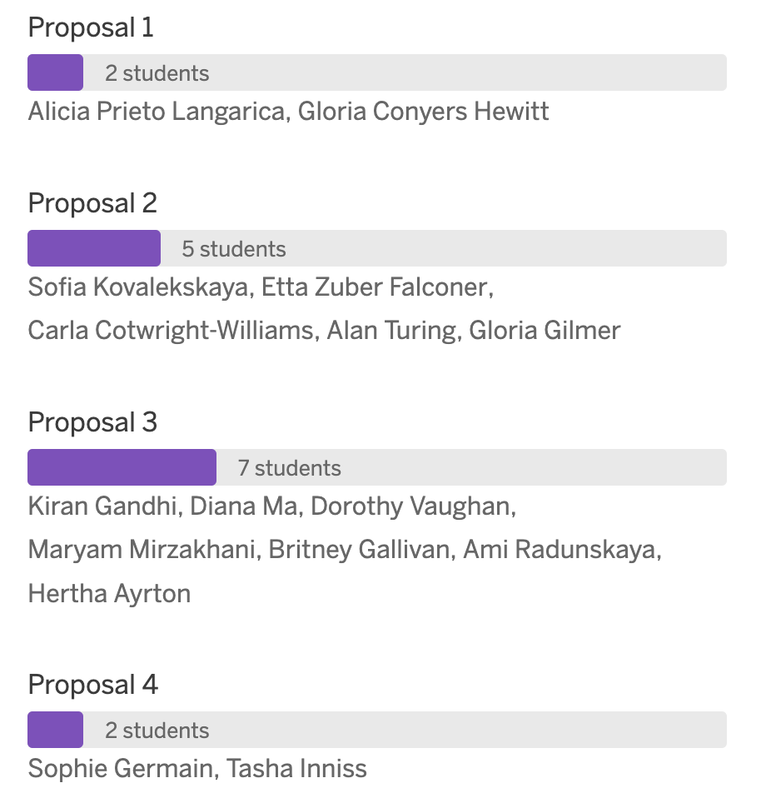

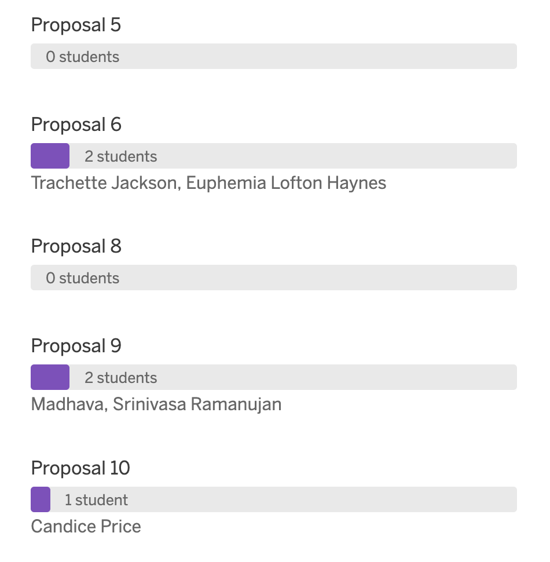

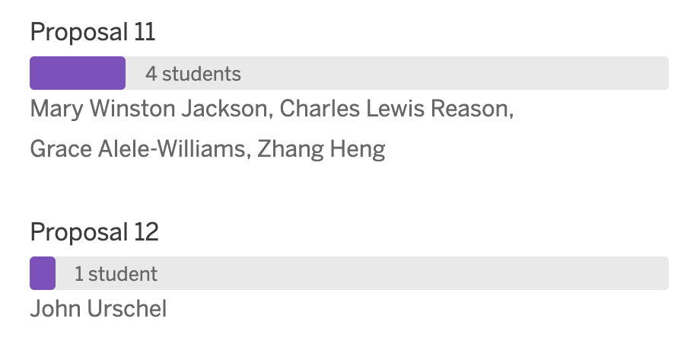

## Proposals Rationale

### Proposal 2

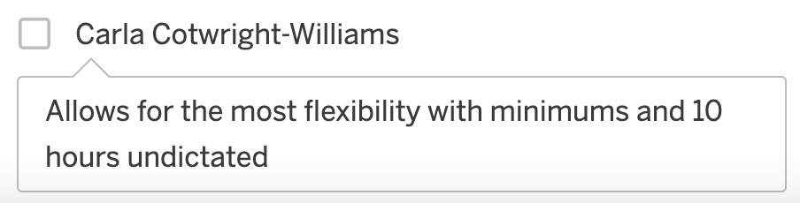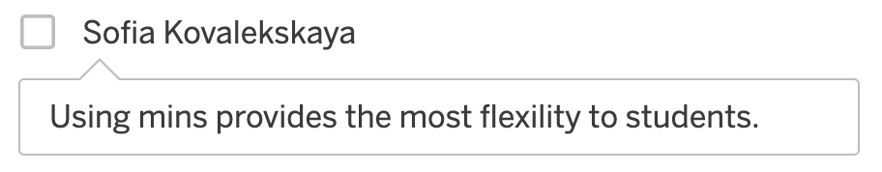

### Proposal 3

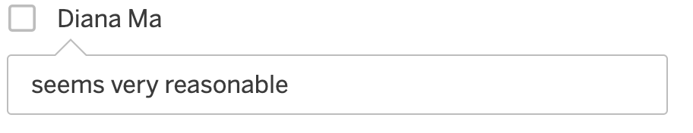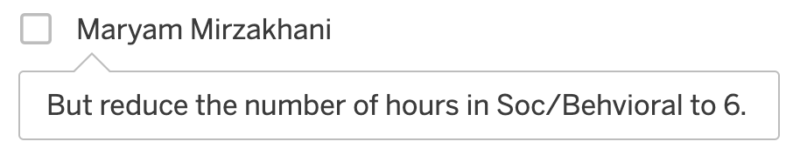

### Proposal 9

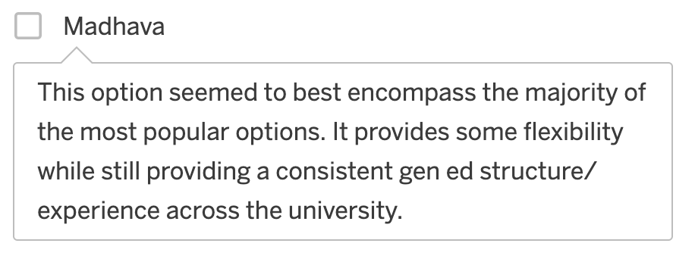

### Proposal 11

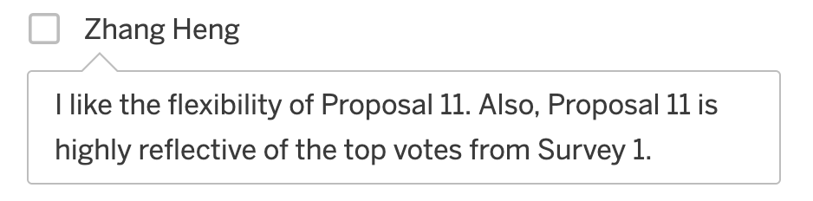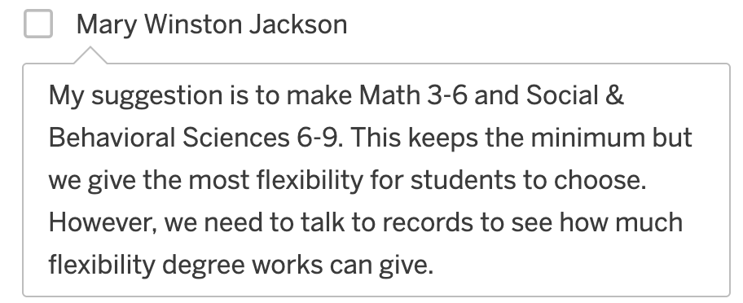

# Final Thoughts

Do you have any ideas/comments to share with the group that you haven't already shared in a previous survey or previous slide?

